Figure 1. Pools with large woody material providing hydraulic elements that promote scour and deposition to maintain preexisting pool structure.

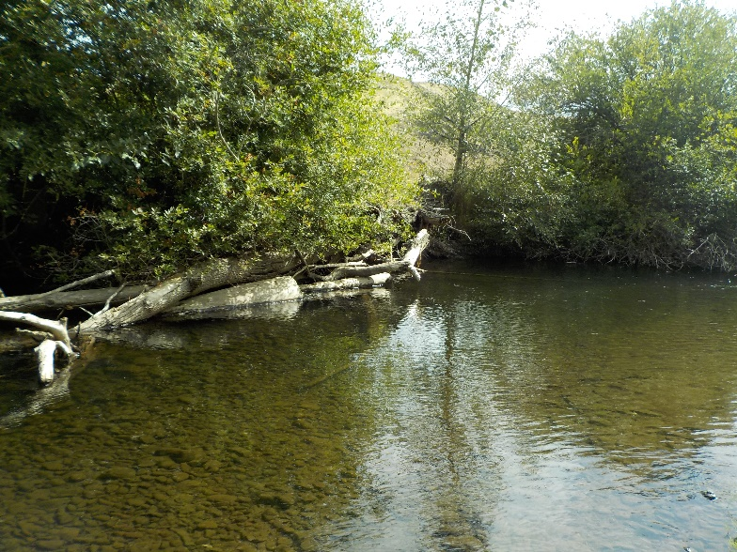
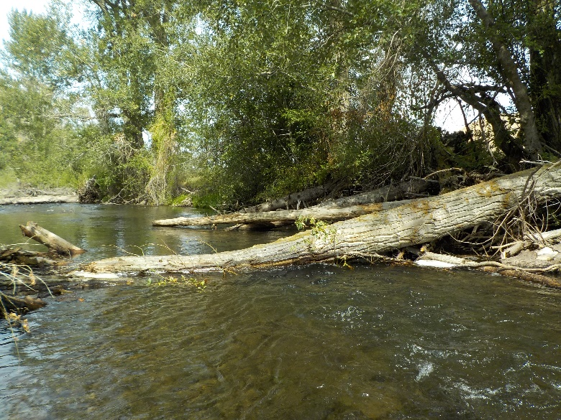

Figure 2. Varying ages of cottonwood, coniferous trees and herbaceous growth. Both planted and natural recruitment.

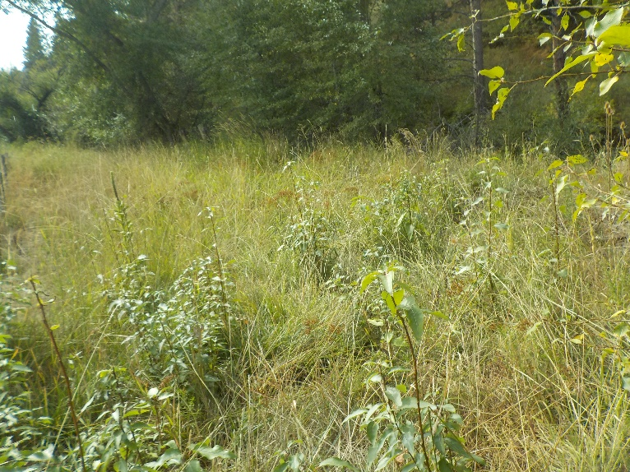
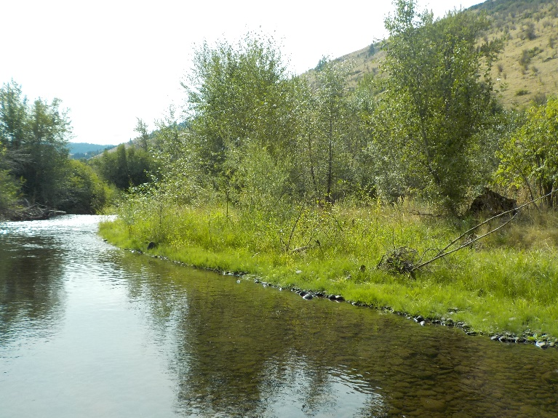

Figure 3. Riparian growth in constructed side channel habitat. Varying age classes of both willow species and cottonwood providing shade to different habitat types (pool and riffle).

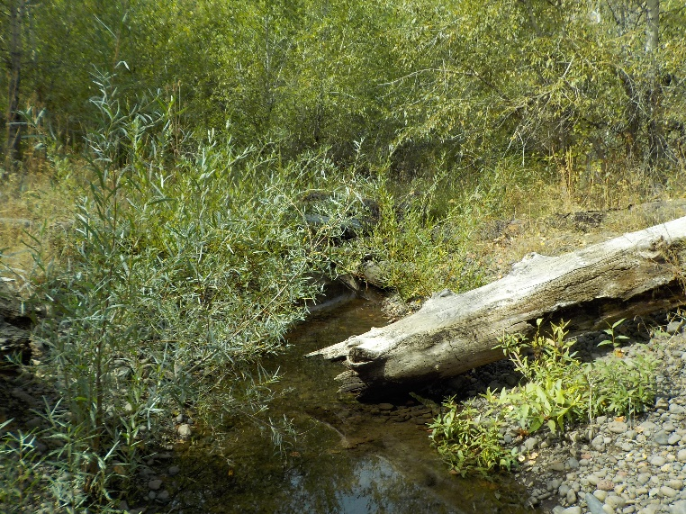
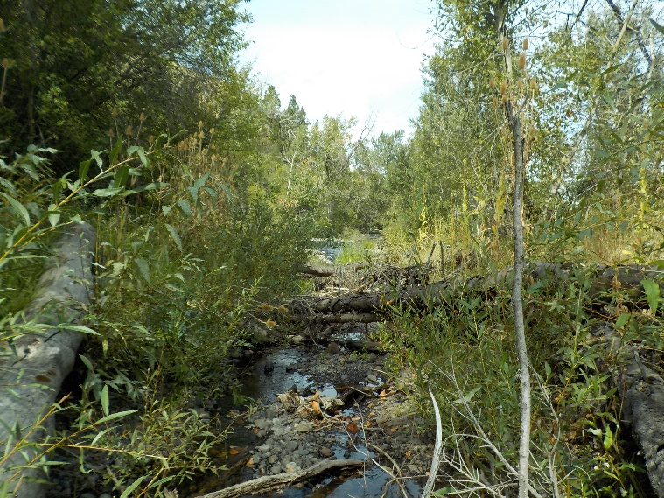

Figure 4. Looking upstream at gravel bar. Note pre project relic channel and preexisting rip rap for bank scour.

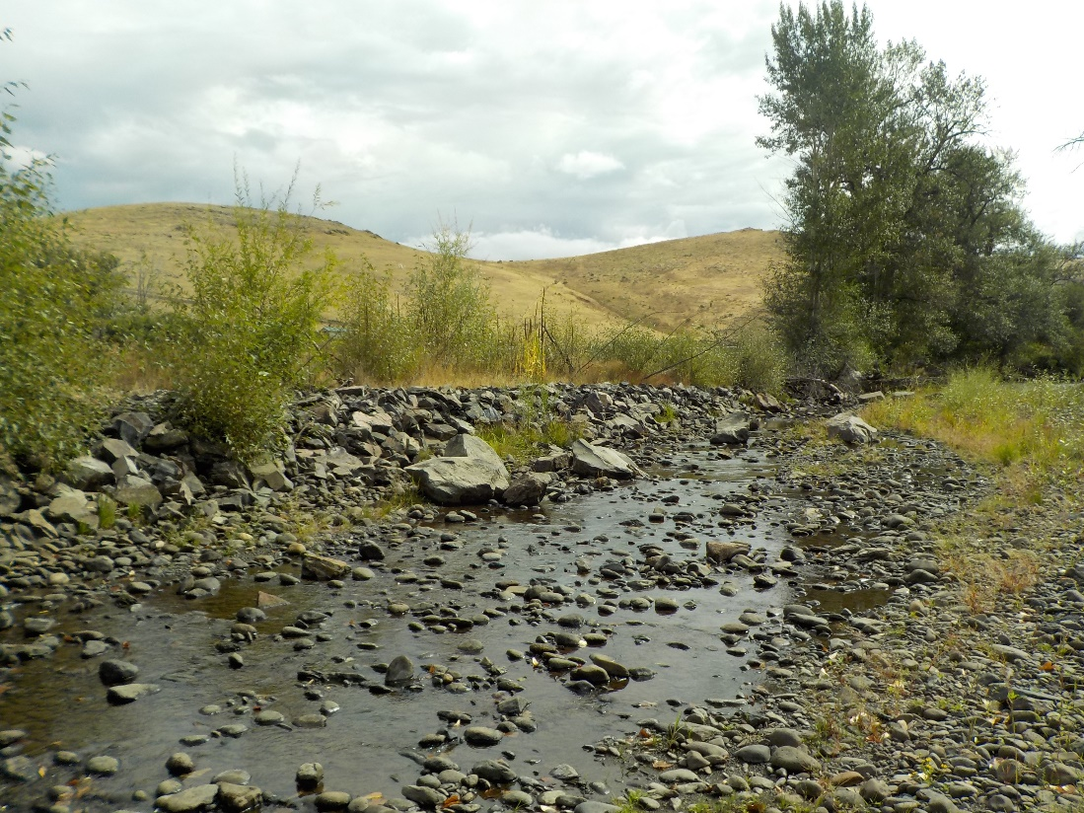

Figure 5. Looking across and downstream at gravel bar. Apex structure added to promote scour of downstream run and deposition on gravel bar.

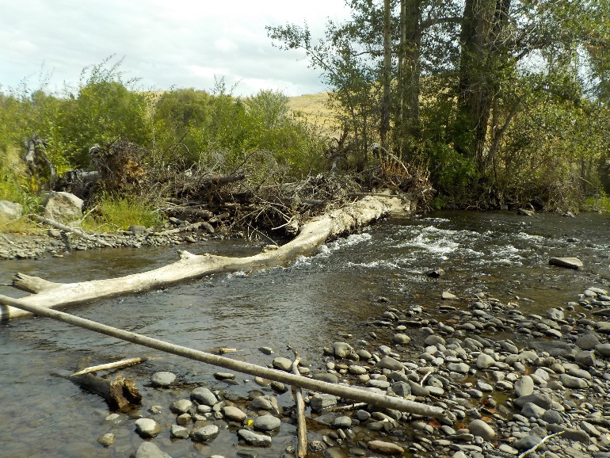
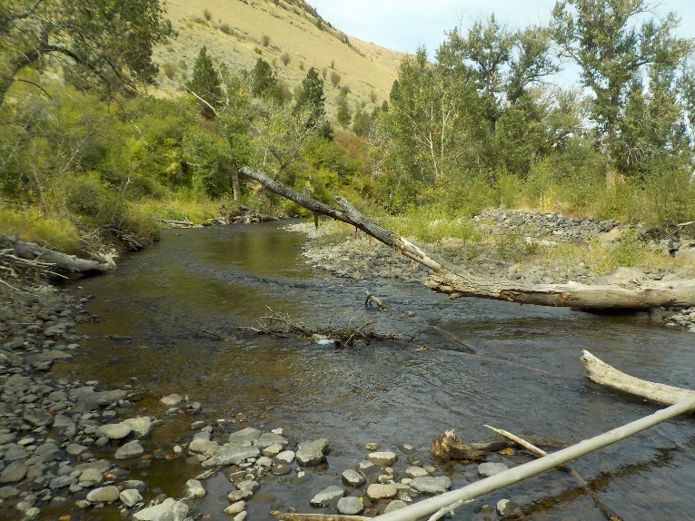

Figure 6. Looking across to project area from river left. Riffle providing scour which is increasing bank instability.

