Grande Ronde Basin Stream Flow Gauging Stations Operation

Water Years 2021

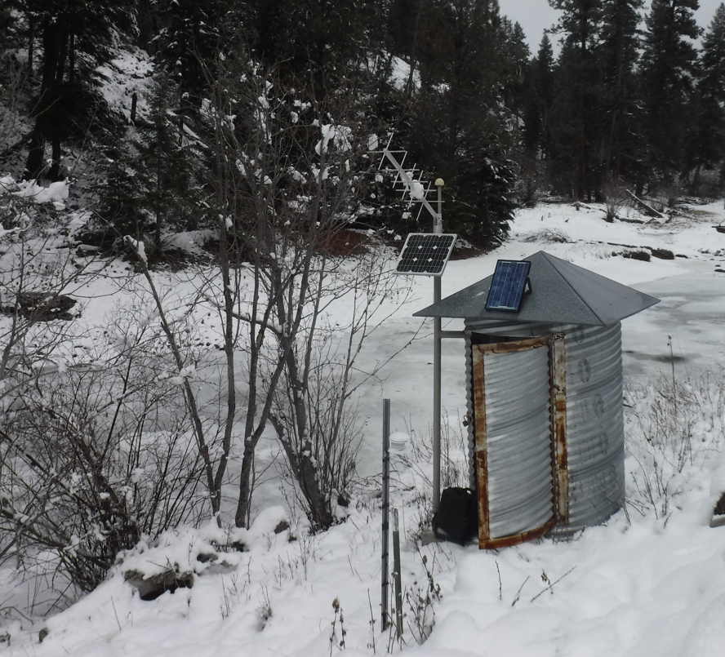
Site 13318210 Meadow Creek below Dark Canyon near Starkey facing upstream.

Kayla Morinaga
Grande Ronde Model Watershed
September 2022
The main monitoring objective for the Grande Ronde Basin Stream Flow Gauging Stations Operation – Water Year 2022 is to continue without lapse the operation, maintenance, review and record
production for twelve stream flow gauges in the Grande Ronde Basin (GRB). Many of the gage stations in this network installed in the early 20th century were for irrigation purposes but they all have evolved to meet diverse objectives, such as:
- To characterize headwater stream contribution and basin outlet data
- They help in predicting and monitoring flood events
- The data assists in accurate hydraulic modeling for the design of fish restoration and passage projects and helps in project planning and implementation
- Fisheries facilities use it for their operations
- Gauge station data is used for instances where there is instream flow conservation, such as water rights leased for instream use that have been overseen by The Freshwater Trust and more recently Trout Unlimited
- Fisheries and climate researchers use the data in their analysis and models
- Data is used in basin wide management plans such as TMDLs, Subbasin plans, agency action plans, and others and they help manage surface flows during irrigation season for irrigation water managers and OWRD.
The project follows accepted USGS standards and protocols for flow measurement, data collection, analysis and reporting. This protocol is the standard flow gauging technique, rigorous, and is accepted in the scientific community. For more information regarding the protocol see Measurement and Computation of Streamflow here: http://pubs.usgs.gov/wsp/wsp2175/. The linked publication is older (published in 1982), but OWRD staff stated that this USGS protocol and procedures document it is the tried and true gold standard to this day.

The 12 sampling locations that were chosen to be funded were already in operation when GRMW assumed coordination and management of these 12 gauge stations in 2006, and it has remained the same since then. The design provides the following:
- Real time flow data provides the ability to manage surface flow during irrigation season.
- Real time flow data provides fisheries professionals the ability to manage fisheries facilities based on stream flow conditions.
- Stream flow records provide restoration project teams the ability to design and engineer restoration actions based on empirical data rather than modeled conditions.
- Stream flow records provide important supplemental data to fisheries research programs and climate scientists.

The selection of the locations for the five gauges operating in Wallowa County have been strategically placed to document several flow characteristics including:
1. Bracket the effects of irrigation withdrawal on the Lostine River, Bear Creek, and the Wallowa River (above Cross-Country Canal to lower end of Wallowa Valley below all irrigation withdrawal). These gauges document water in and out of irrigation-influenced reaches.
2. Station #13330000 (Lostine R. near Lostine) and 13330500 (Bear Cr. near Wallowa) are long-term installations established in the early 1900’s. Their continued operation serves as a reference data set by which cumulative effects can be assessed.
3. Station #13331450 (Wallowa R. below Water Canyon) documents water leaving the Wallowa Valley.

The five USFS gauges in Union County on National Forest land have been strategically placed for the following reasons:
1. The data will characterize the hydrographs for long term monitoring of the potential effects of management activities on stream flow and the effectiveness of restoration activities directed at meeting desired conditions.
2. Stream flow data will be used to correlate monitoring parameters such as air temperature, solar radiation, relative humidity and yearly variation in instream habitat parameters.
3. These data, in conjunction with historical records of stream flow for the Grande Ronde River near Perry (gauge #13318960), provide for long term, comprehensive characterization of stream flow for the Upper Grande Ronde (UGR) River Drainage.

The two OWRD gauges in Union County (not on National Forest land) have been placed to document the following flow characteristics:
1. When compared to the Upper Catherine Creek gauge Catherine Creek at Union brackets irrigation withdrawal above the town of Union and informs the communities downstream of rising waters during high flow events.
2. The Grande Ronde R. near Perry site documents the amount of water leaving the UGR above the town of La Grande. This site is critical to four of the five USFS sites and its continued operation strengthens a long-term data set by which cumulative effects can be assessed and informs the communities downstream of rising waters during high flow events.

In addition to the stations that this agreement helps fund, nine additional gauges exist that strengthen the overall flow-monitoring network.

Sample sites are shown in Figure 1 with green circles denoting the gauge stations that were partially funded through this contract. All other colored circles are gauge stations fully funded by other agencies.
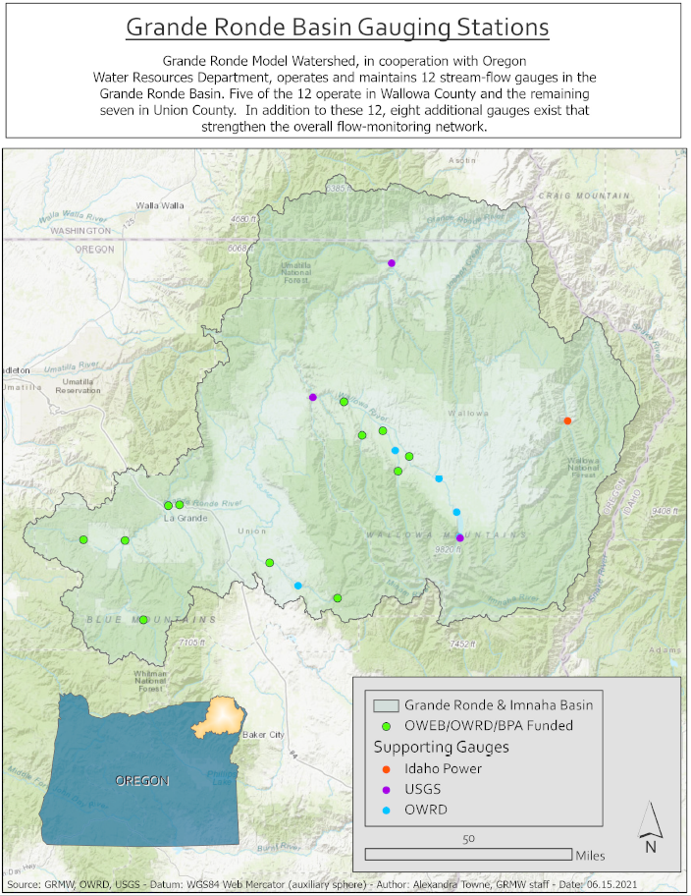
Figure 1. Map of gauge station locations in the Grande Ronde Basin.
All data on the OWRD Near Real Time Hydrographic Data website is in provisional status until it has received checks and reviews by the Salem hydrographic team which can take many years. When you navigate to the website select “Grande Ronde Basin” in the drop down list for basin selection. Currently the data for most of these Grande Ronde sites is still provisional pending final review from 2012 to the present. Provisional data is available and still used dependent on the requirements of the user.

The following project objectives are being met by the gauge station data set and real time availability:

Objective #1 - Provide real time flow data to assist in irrigation water management for both irrigators and OWRD in the GRB. Examples of this monitoring objective include:
1. Coordination between irrigators, ODFW and Tribes by which irrigation diversion amounts are reduced to accomplish fish passage in seasonally low flow irrigation influenced streams.
2. Provide real time flow data that allows OWRD staff the ability to efficiently regulate irrigation withdrawal.
3. Provide real time flow data to both irrigators, The Freshwater Trust and most recently Trout Unlimited that provides for the implementation and substantiation of seasonal water leases in both Union and Wallowa Counties.

Objective #2 - Provide flow data to assist fishery managers in the Grande Ronde Basin informing the safe and effective operation of fisheries management actions and facilities operations. Examples of this
monitoring objective include:
1. Real time flow data informs fisheries managers when stream flow is at critical low levels and trap and haul efforts are required to transport migrating fish above low flow reaches.
2. Stream flow data informs when temporary facilities can be installed and when they need to be removed, like when dewatering a stream segment for stream restoration instream construction.
3. Stream flow data informs when fish weirs and screw traps can be activated and when they need to be removed to avoid stressing the fish.

Objective #3 – Provide flow data to assist in conservation and restoration project development in the Grande Ronde Basin. Examples of this monitoring objective include:
1. Provide empirical data necessary to develop hydraulic models required in many stream restoration actions. This is very important and used heavily by engineers designing projects and also for creating flow scenarios in the Grande Ronde valley where flooding has been a key local issue in recent years.
2. Basin hydrology research is simplified and more representative of actual conditions with stream flow data available and making more accurate predication.

The gauge station data, both historic and real time, is used when a stream restoration project is being designed, intensively when an instream project is being constructed, and for research purposes. The data is used for flood forecasting and community safety, agricultural practices, administering water right, and for recreationalists. OWRD does not generate a technical/annual report for each site anymore since all of the records are available online over the past 15 years. The OWRD website has near real time hydrographic data for most sites. The gauge station data is critical and has been used continually in the following research programs and documents to name a few:

Oregon Department of Fish and Wildlife (ODFW)

Sedell, E. R., J. W. Dowdy, B. C. Power, G. A. McMichael, E.N. Branigan, K. J. Wauhkonen, E. R. Warnock, C. A. Derrickson, N. J. DeVanDerSchueren, O. C. Davis, S. D. Favrot, P. P. Gibson and J. R. Ruzycki. 2021. Investigations into the Life History of Naturally Produced Spring Chinook Salmon and Summer Steelhead in the Grande Ronde River Subbasin. Oregon Department of Fish and Wildlife. 2018-19 Annual Report to the Bonneville Power Administration, Project # 1992-026-04, Contract #s 75001 and 74313. La Grande, Oregon.

Nez Perce Tribe (NPT)

Imnaha Smolt and Adult Steelhead Status Monitoring: Referenced in NPT annual reports entitled; Emigration of Juvenile Chinook Salmon and Steelhead from the Imnaha River (1994 – 2020)

Grande Ronde Spring Chinook Monitoring & Evaluation: Referenced in NPT annual reports entitled; Evaluating Spring Chinook Salmon Supplementation in the Lostine River, Oregon (1997 – 2020)

Lostine River Radio Telemetry Project: Referenced in NPT annual reports entitled; Migratory Assessment of Spring Chinook Salmon in the Lostine River Using Radio-Telemetry Techniques (2008 – 2020), Nez Perce Tribe Lostine Telemetry Management Briefs. Chaperone

Confederated Tribes of the Umatilla Indian Reservation (CTUIR)

Grande Ronde Research Monitoring and Evaluation, BPA project # 2007-083-00 and LSRCP project # 475 (F14AC00013). Grande Ronde Subbasin Restoration Project, BPA project # 1996-083-00.

2021 Final Flow Record

