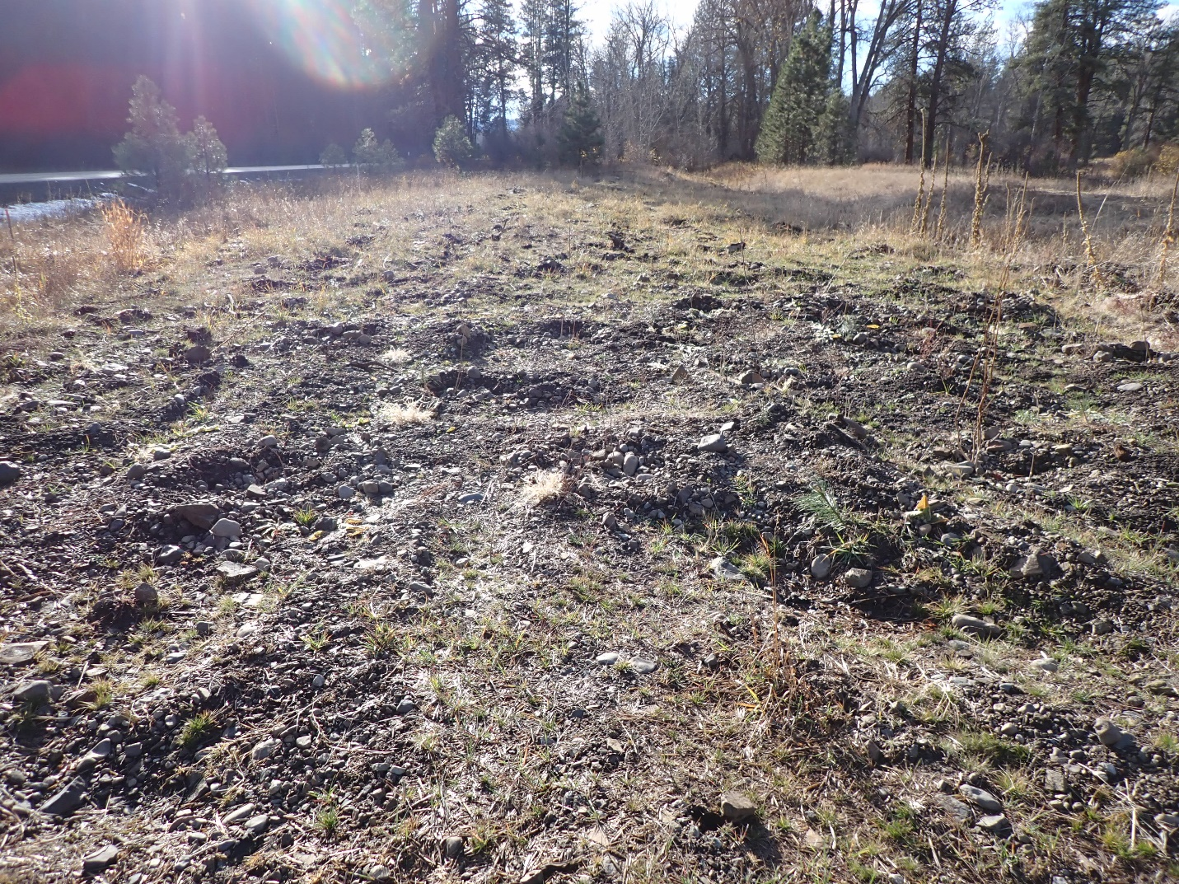
9/16/22 Photo Point 1: Longley Meadows Pre Planting Project

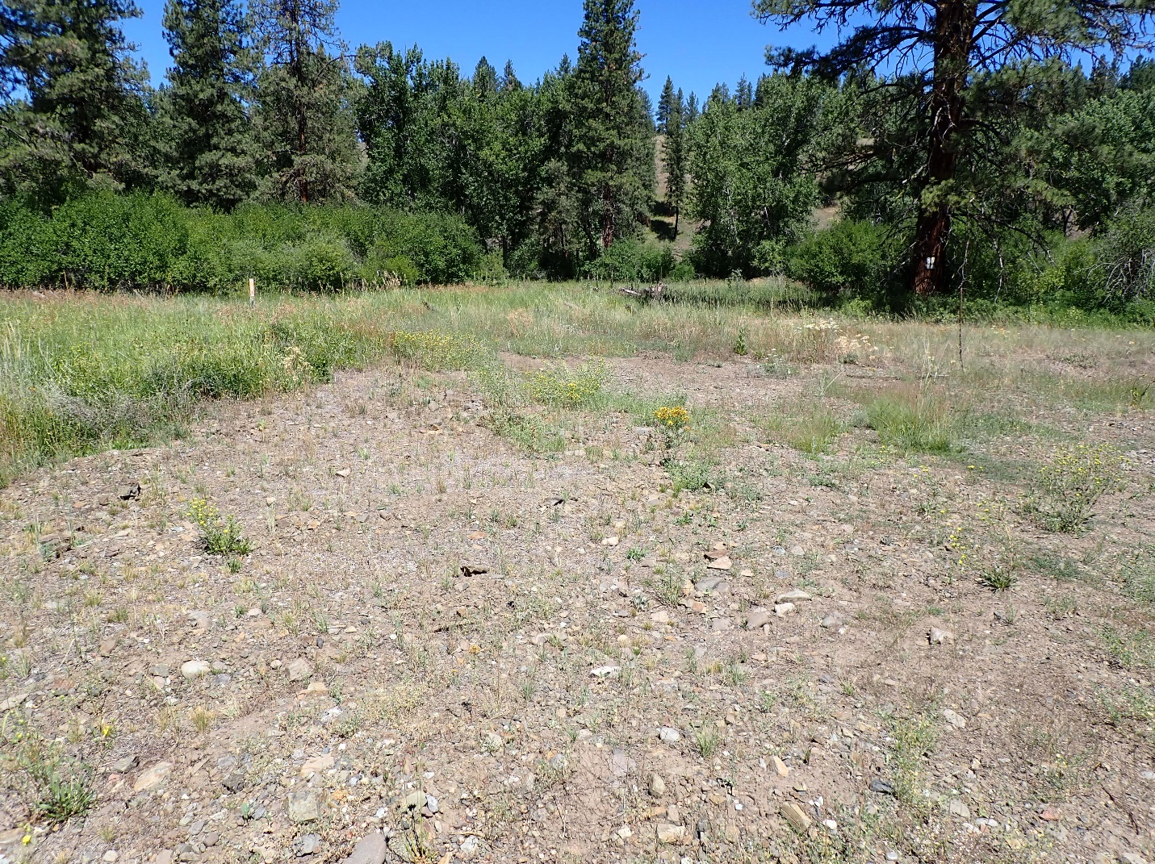
7/14/23 Photo Point 1: Longley Meadows Post Planting Project

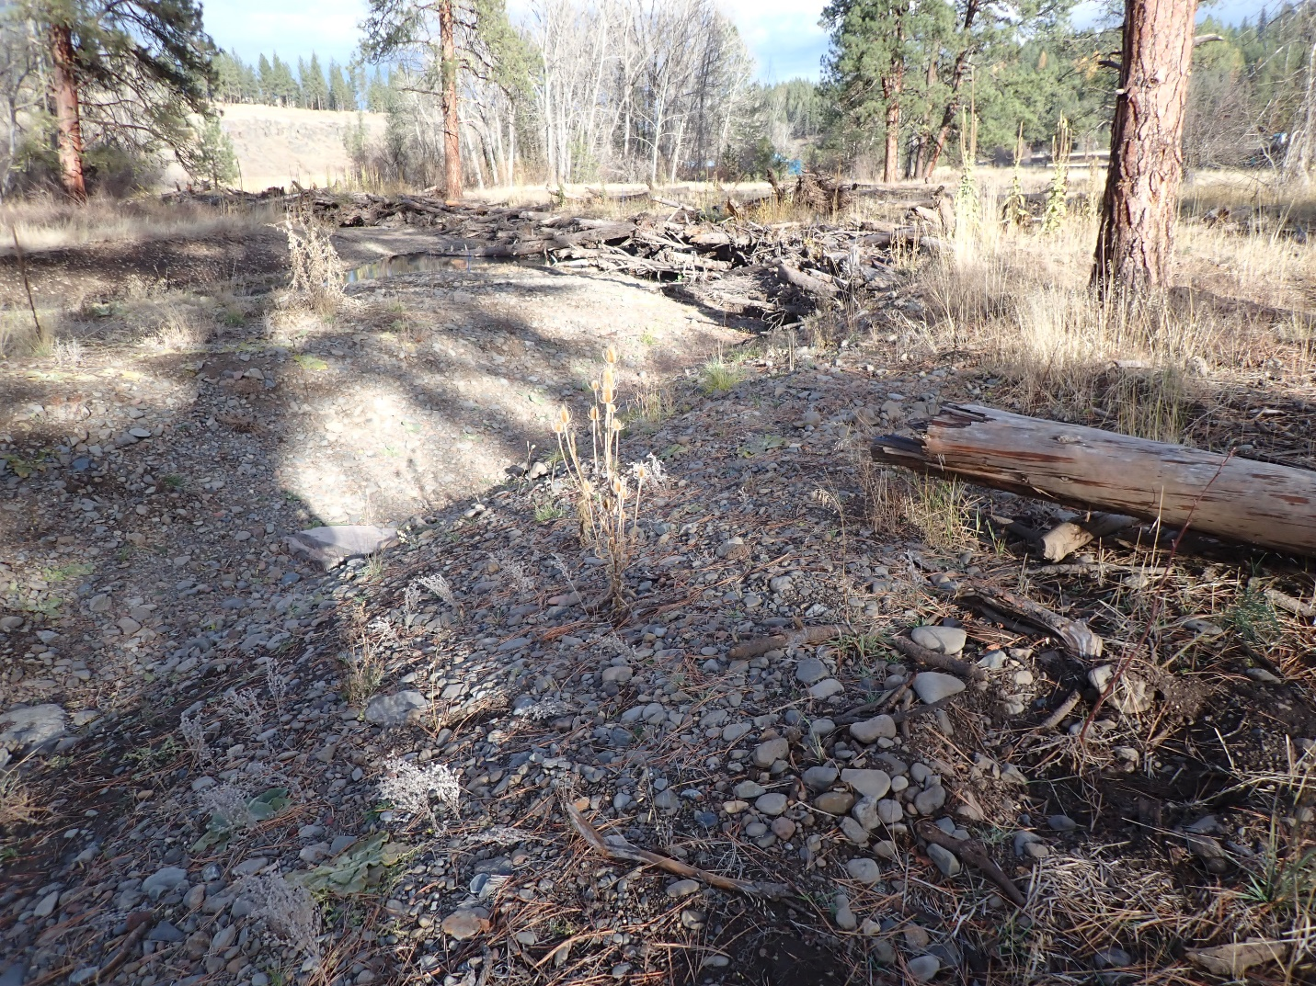
9/16/22 Photo Point 2: Longley Meadows Pre Planting Project
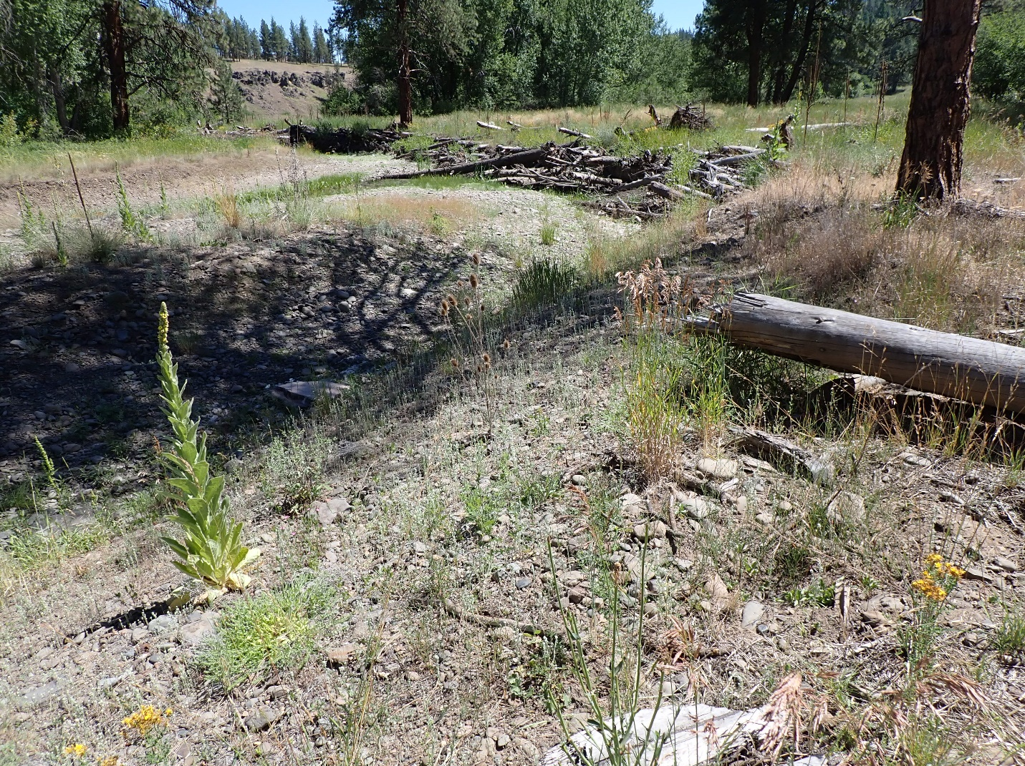
7/14/23 Photo Point 2: Longley Meadows Post Planting Project

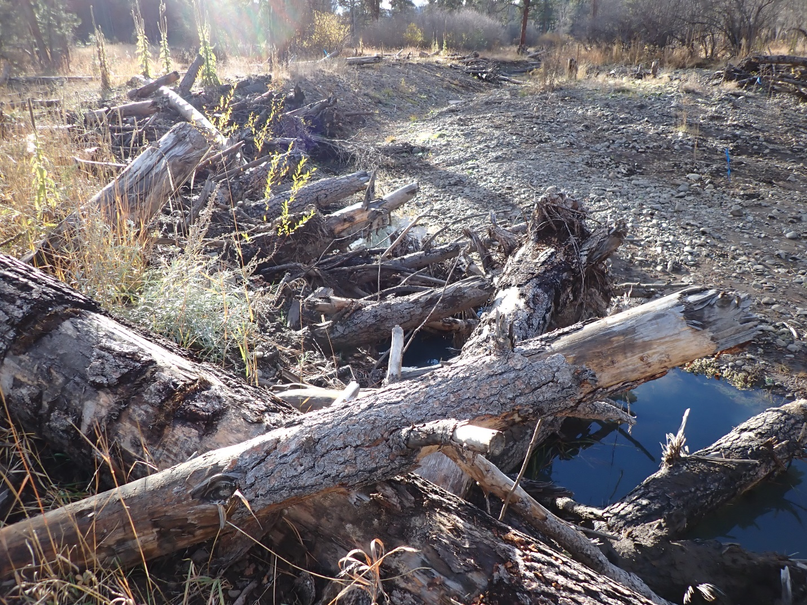
9/16/22 Photo Point 3: Longley Meadows Pre Planting Project
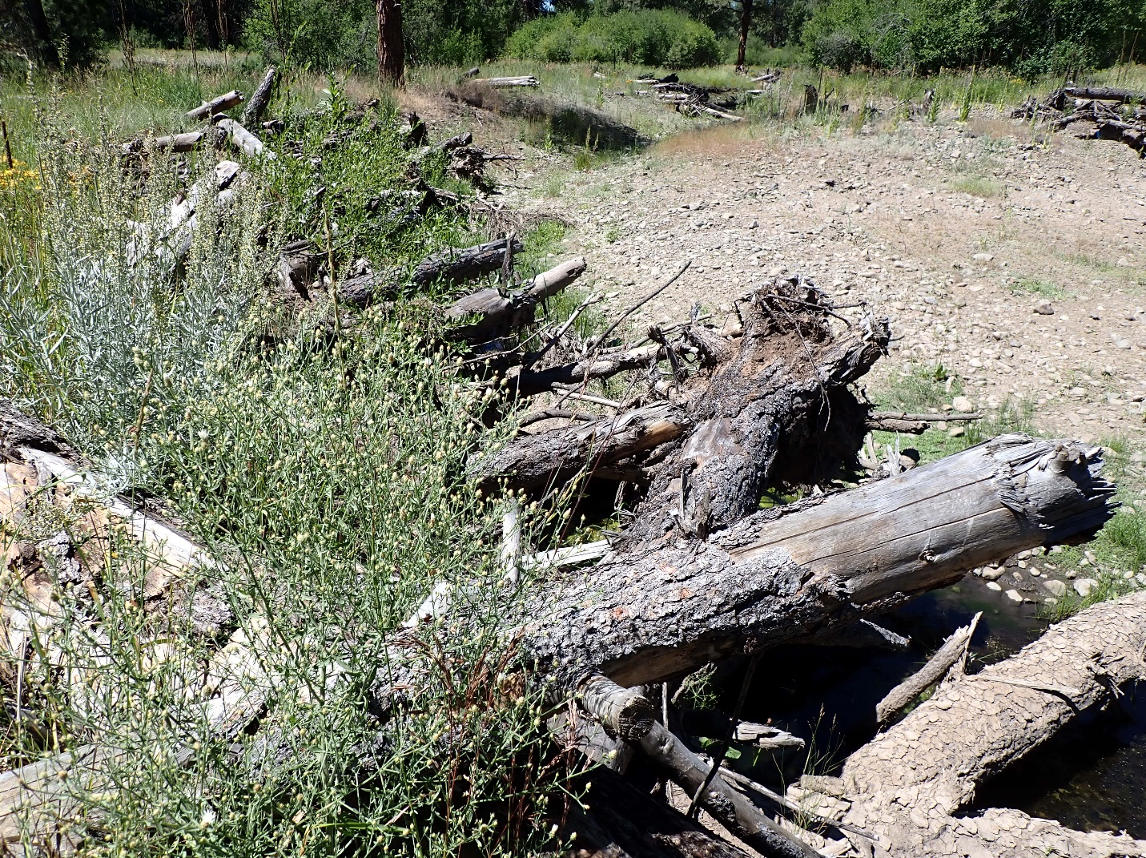
7/14/23 Photo Point 3: Longley Meadows Post Planting Project

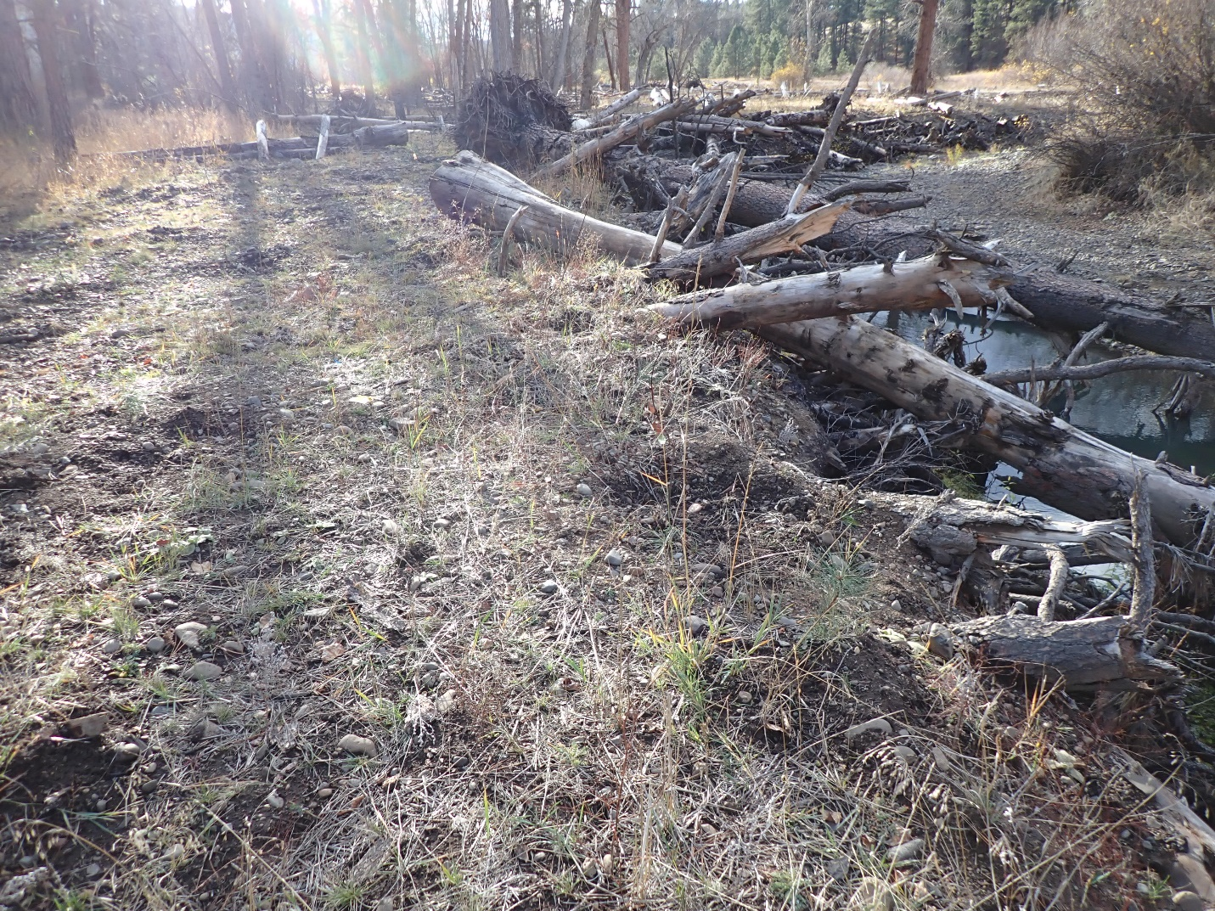
9/16/22 Photo Point 4: Longley Meadows Pre Planting Project
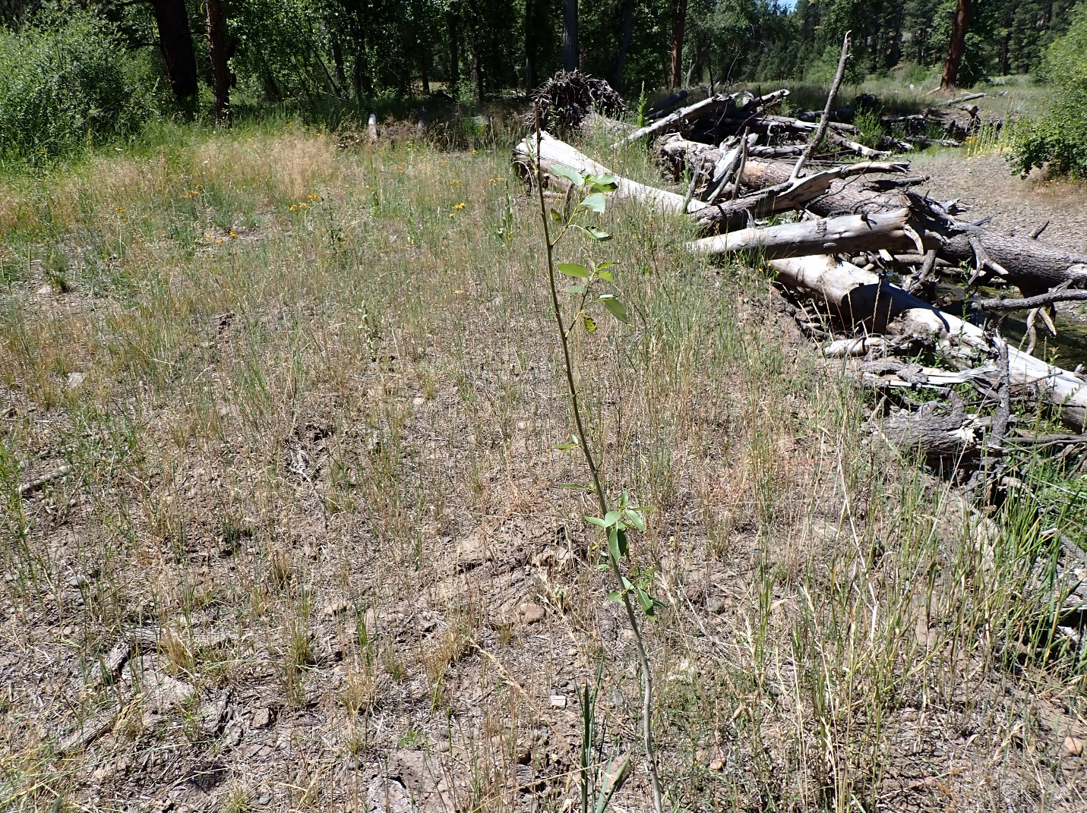
7/14/23 Photo Point 4: Longley Meadows Post Planting Project

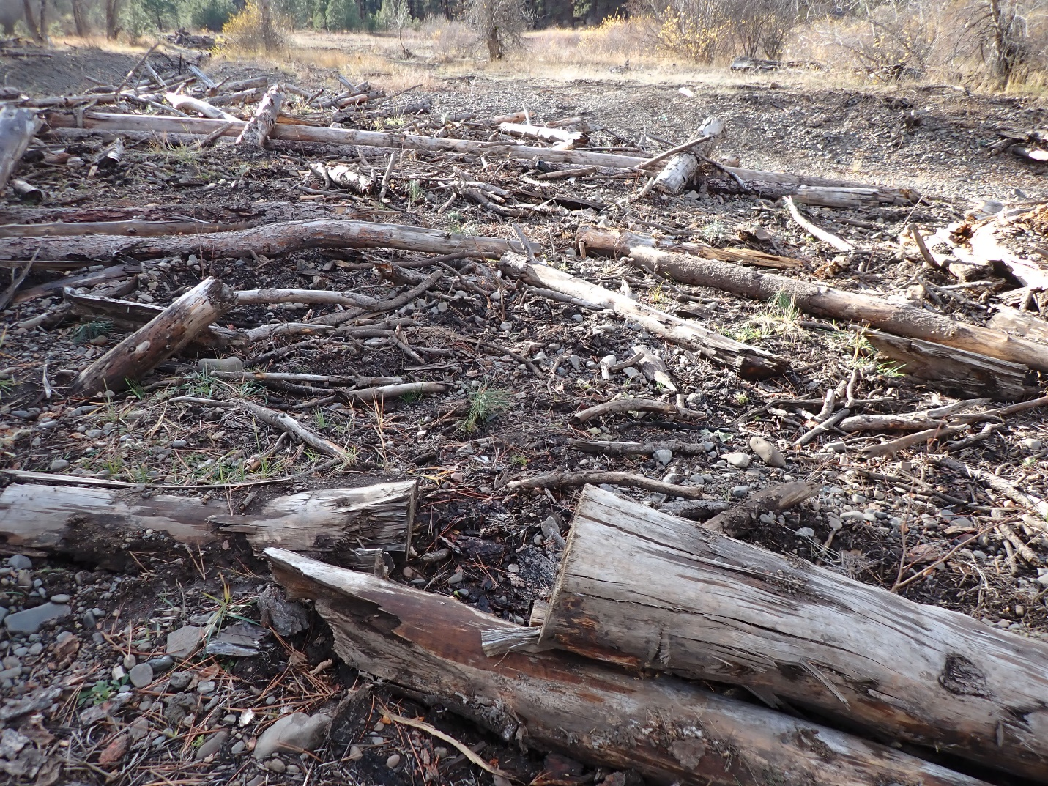
9/16/22 Photo Point 5: Longley Meadows Pre Planting Project
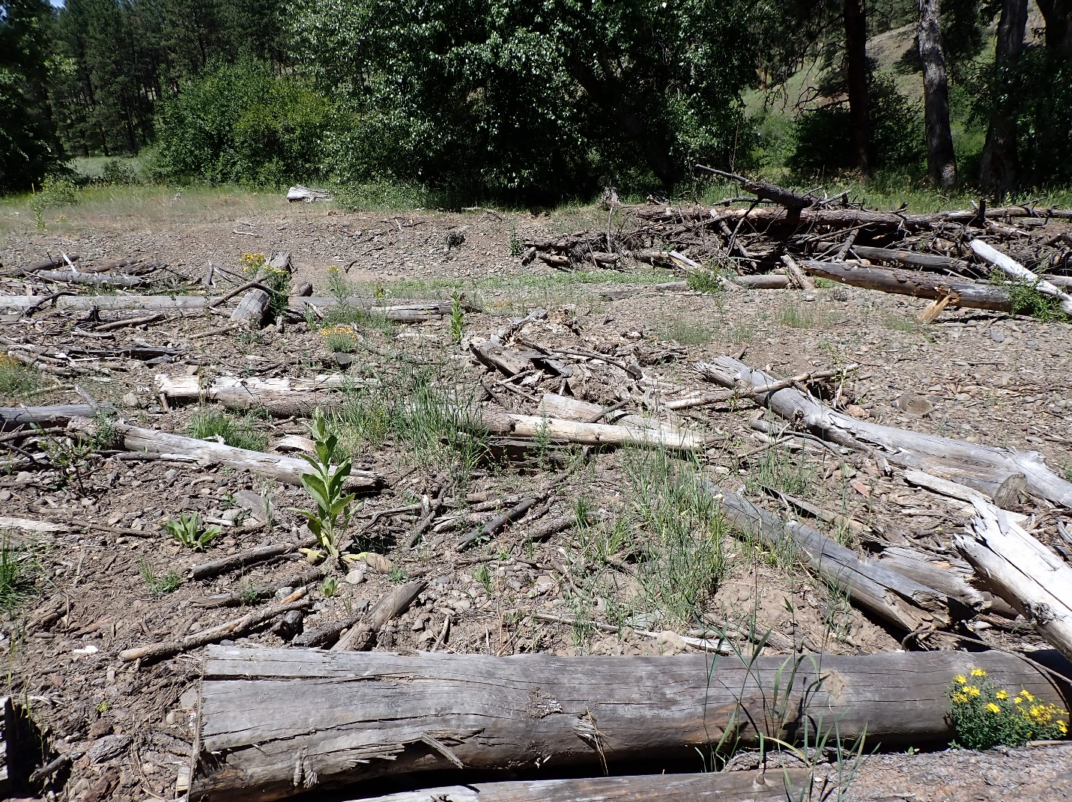
7/14/23 Photo Point 5: Longley Meadows Post Planting Project

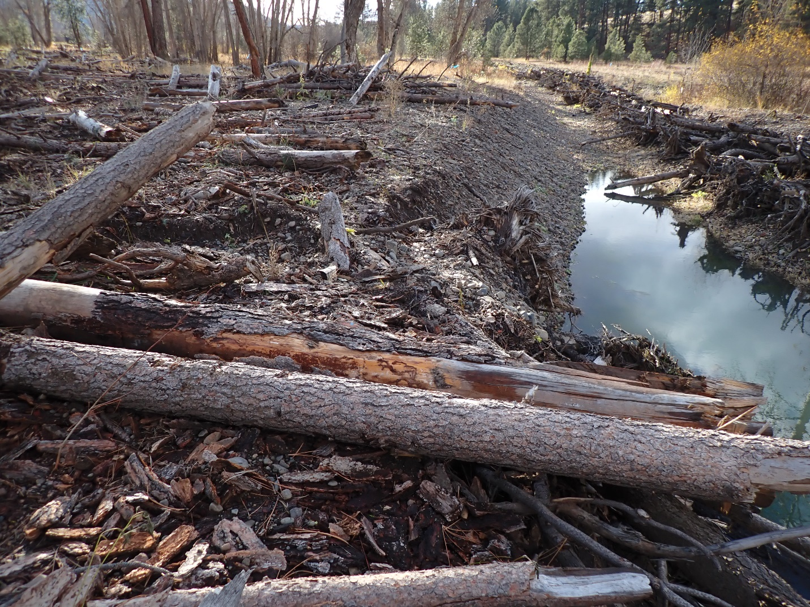
9/16/22 Photo Point 6: Longley Meadows Pre Planting Project
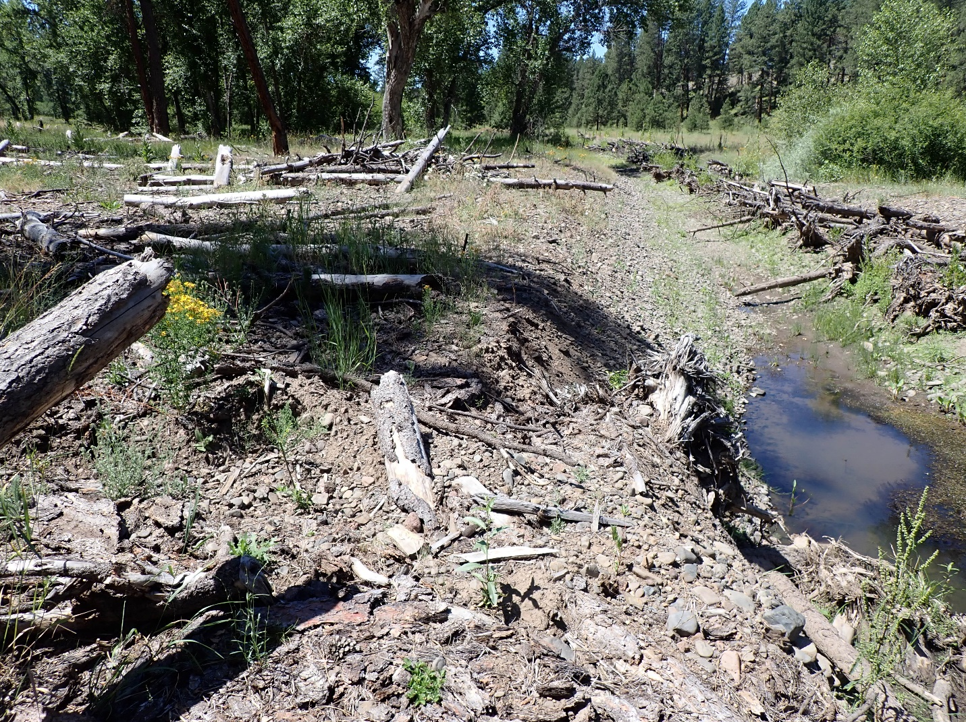
7/14/23 Photo Point 6: Longley Meadows Post Planting Project

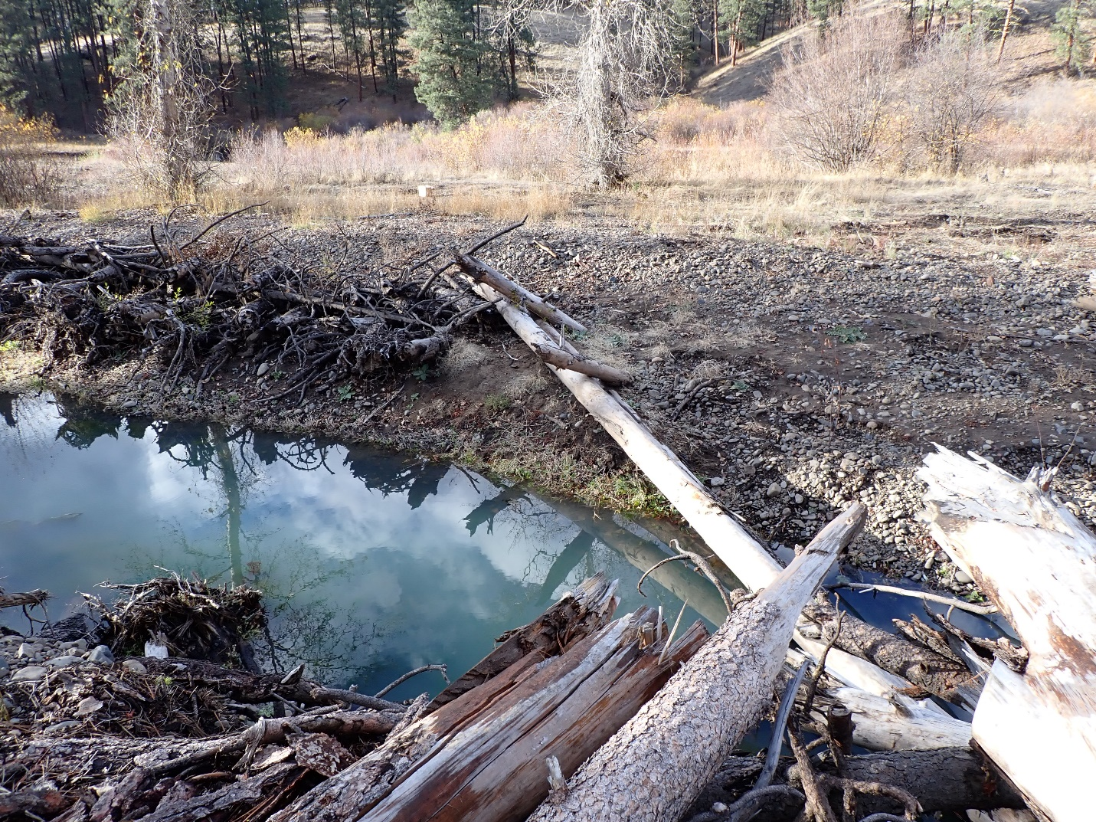
9/16/22 Photo point 7: Longley Meadows Pre Planting Project
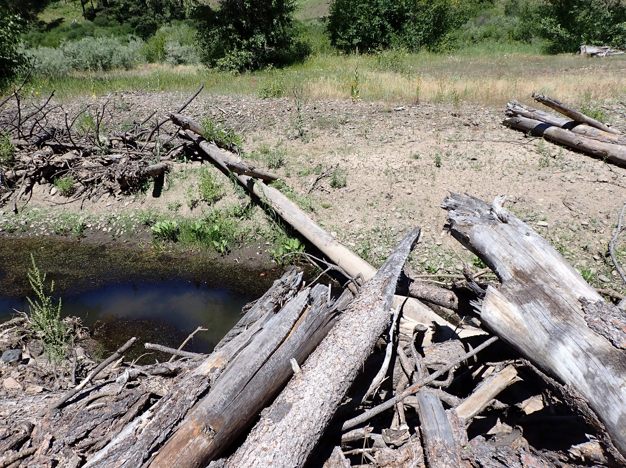
7/14/23 Photo point 7: Longley Meadows Post Planting Project

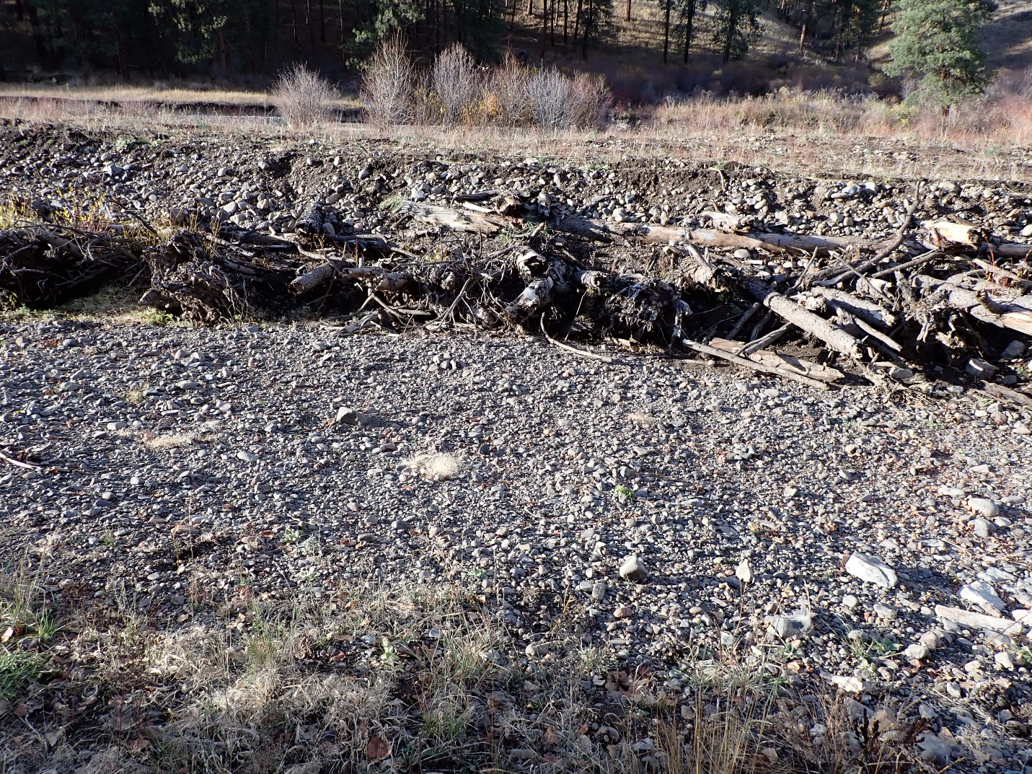
9/16/22 Photo Point 8: Longley Meadows Pre Planting Project
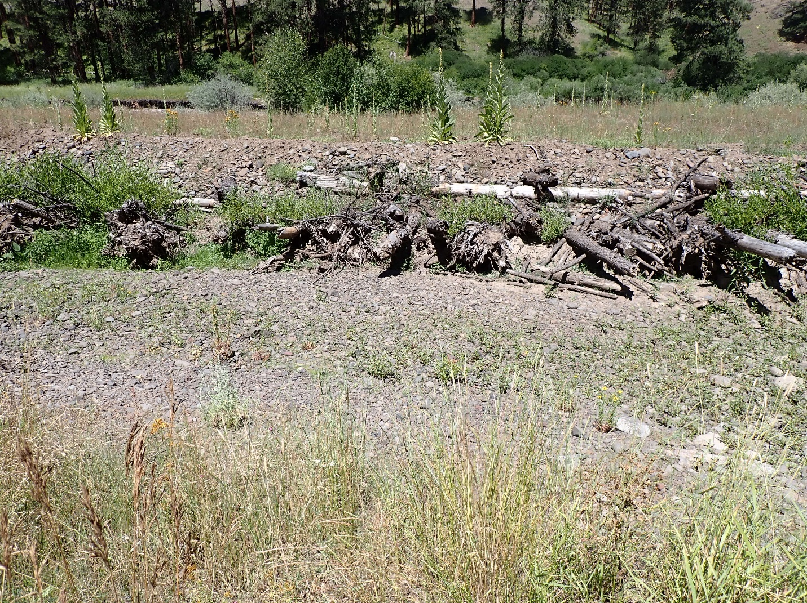
7/14/23 Photo Point 8: Longley Meadows Post Planting Project

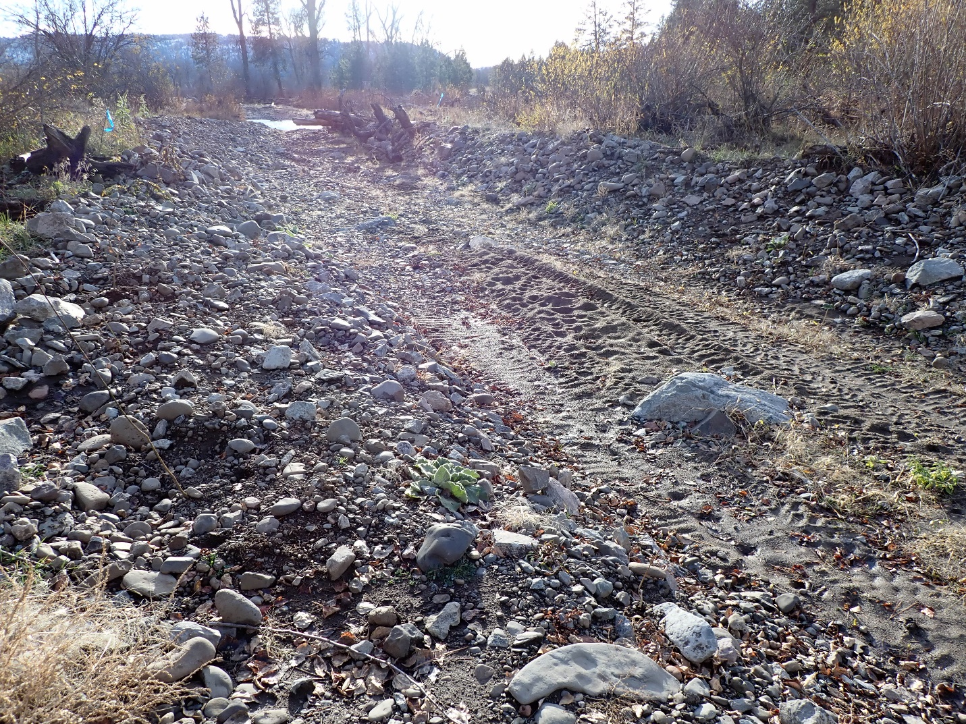
9/16/22 Photo Point 9: Longley Meadows Pre Planting Project

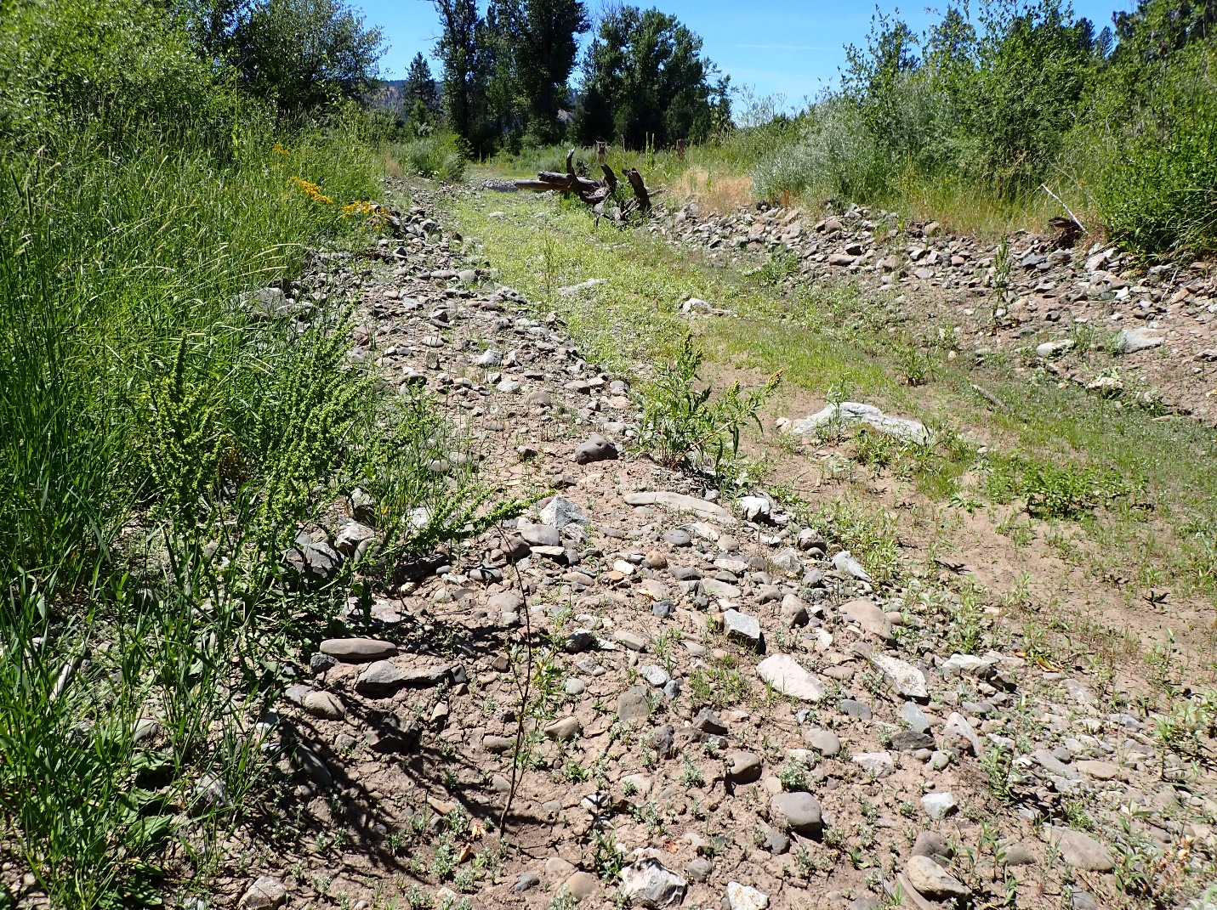
7/14/23 Photo Point 9: Longley Meadows Post Planting Project

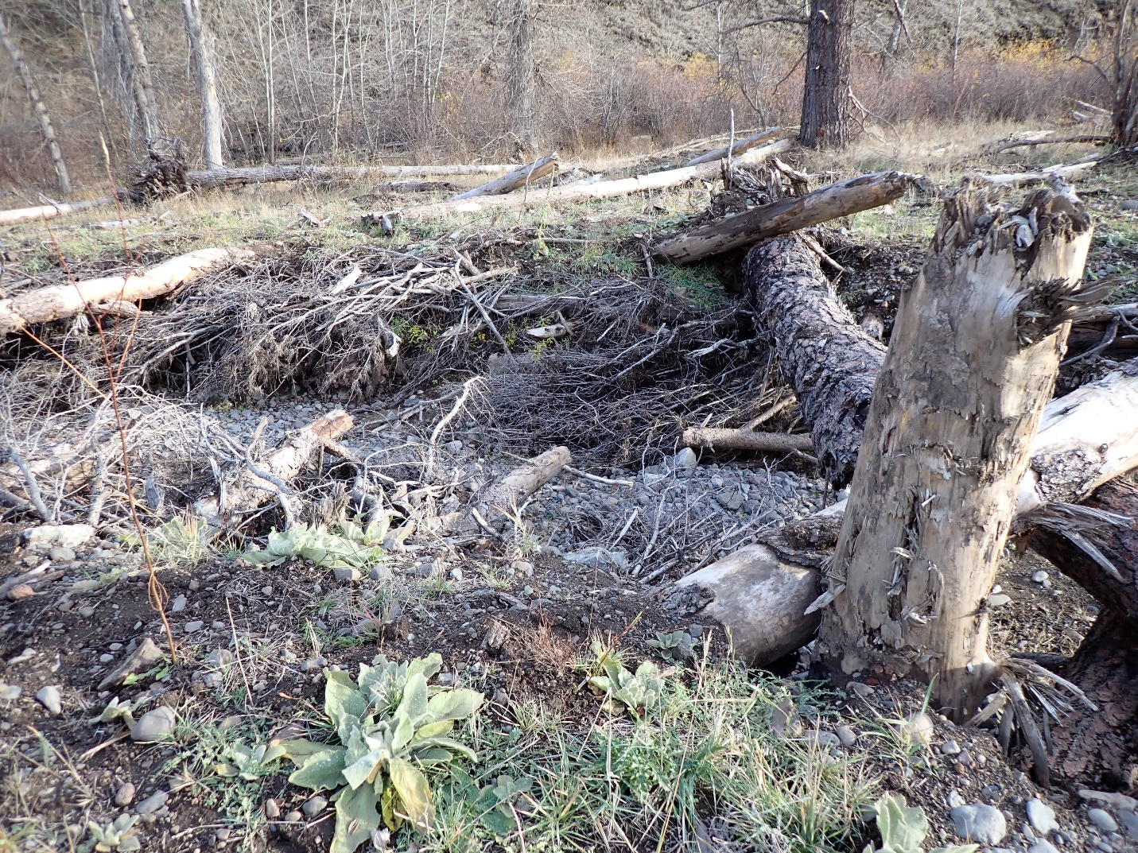
9/16/22 Photo Point 10: Longley Meadows Pre Planting Project
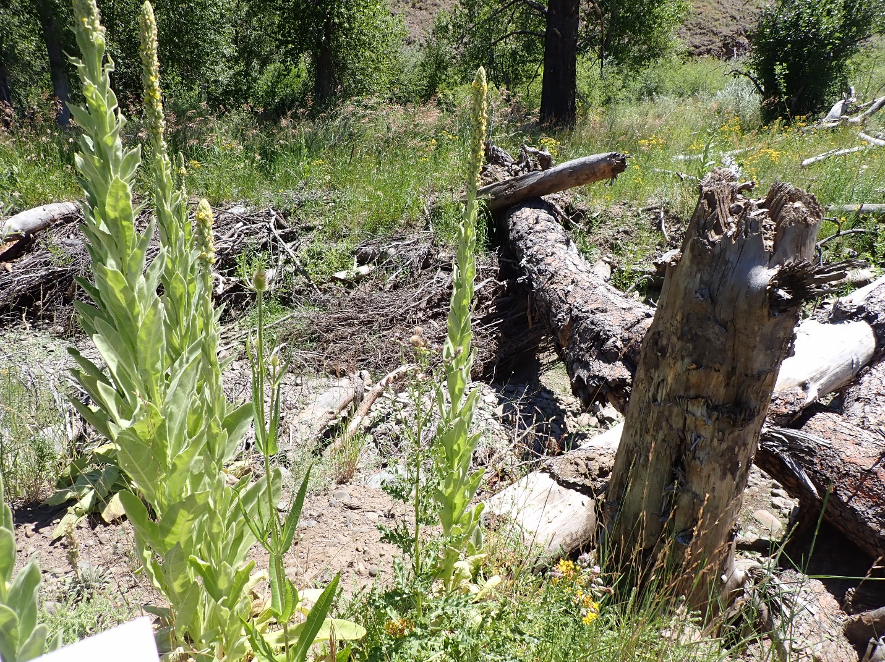
7/14/23 Photo Point 10: Longley Meadows Post Planting Project

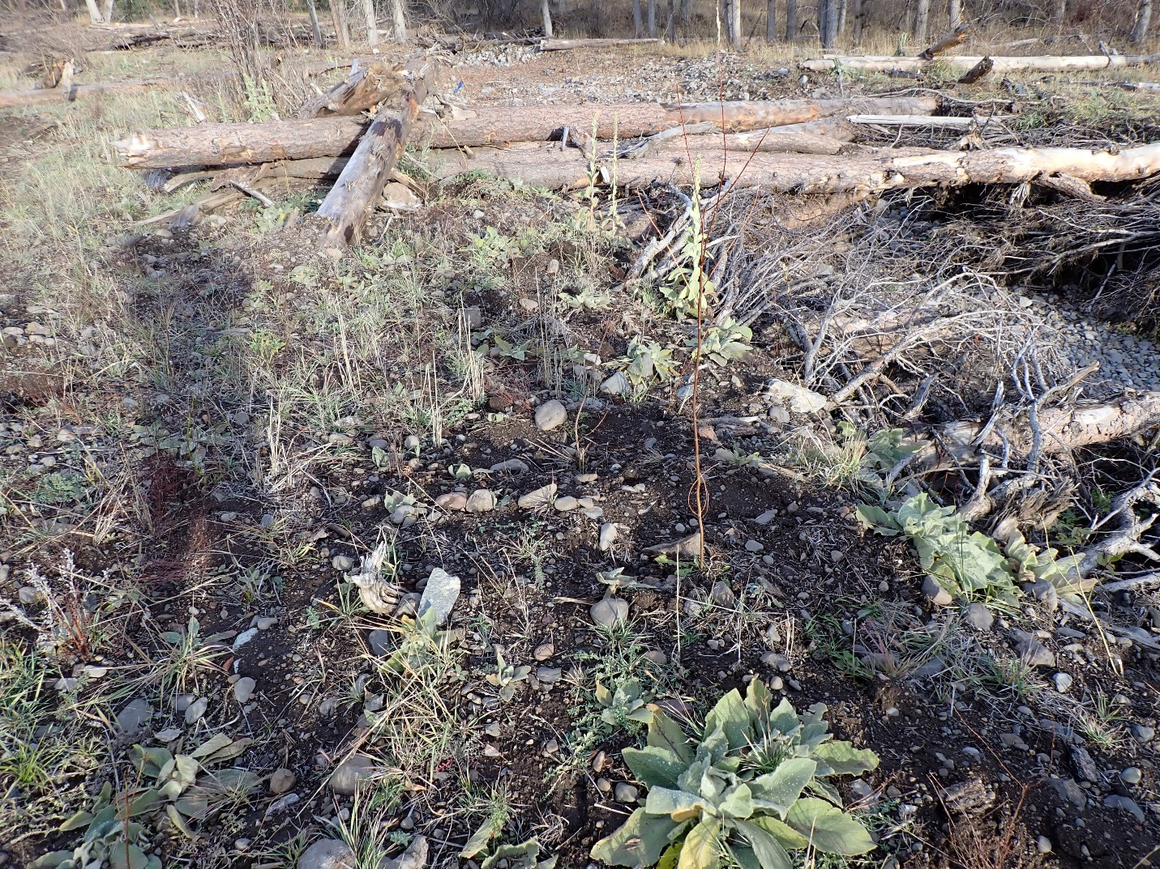
9/16/22 Photo Point 11: Longley Meadows Pre Planting Project
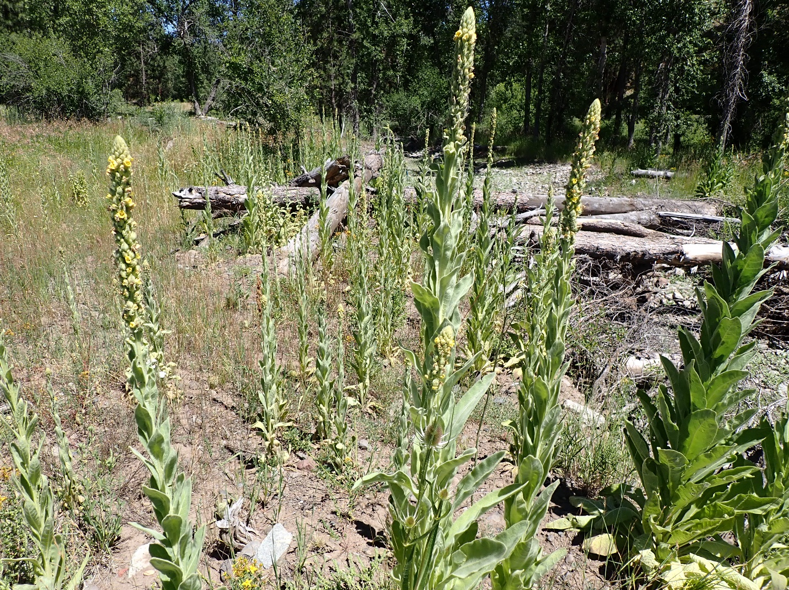
7/14/23 Photo Point 11: Longley Meadows Post Planting Project

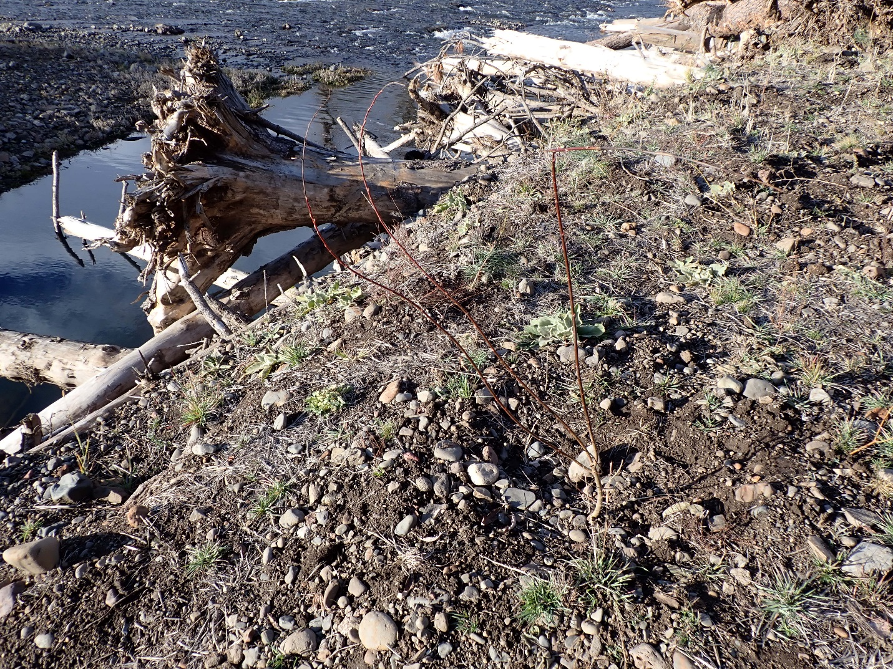
9/16/22 Photo Point 12: Longley Meadows Pre Planting Project
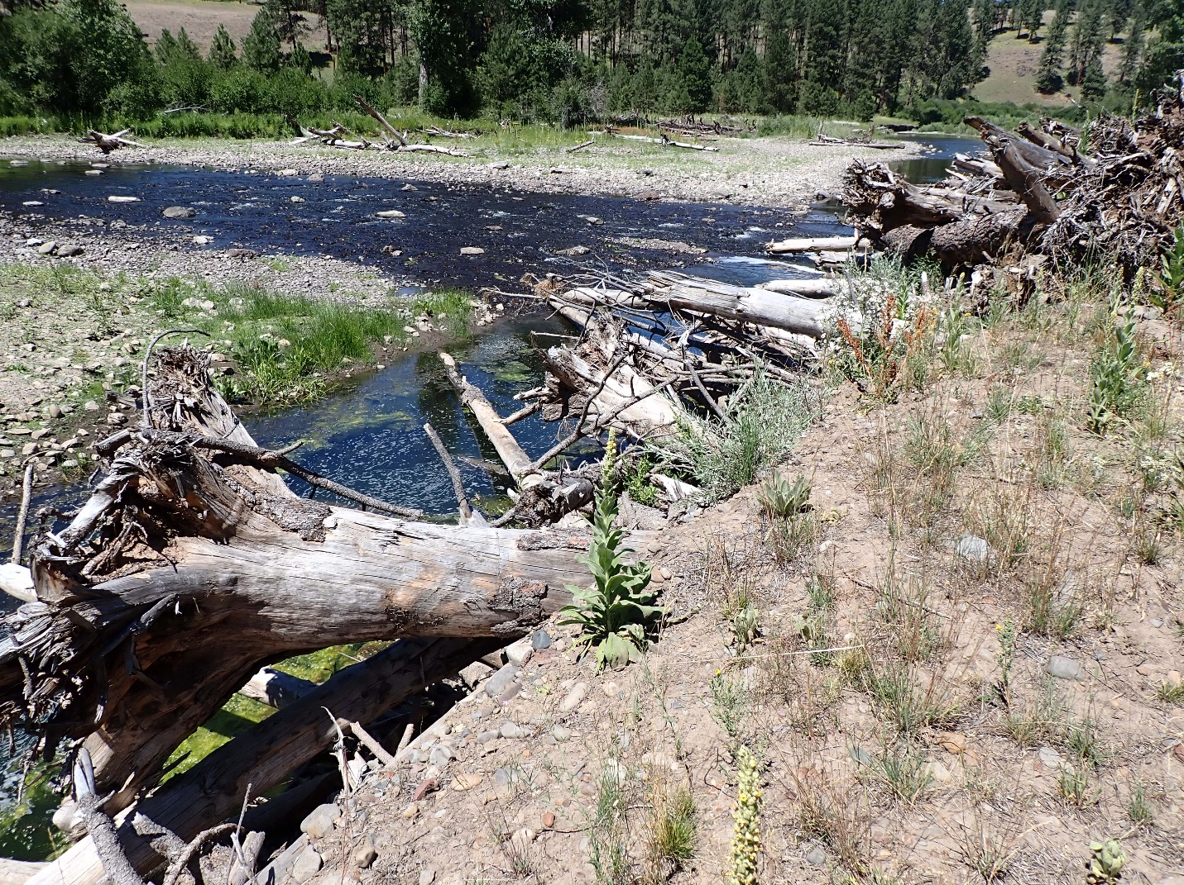
7/14/23 Photo Point 12: Longley Meadows Post Planting Project

