Wallowa Atlas
Implementation Guidelines

Atlas Partners

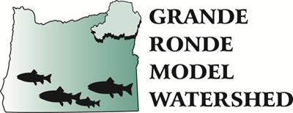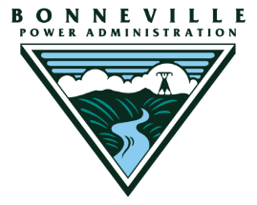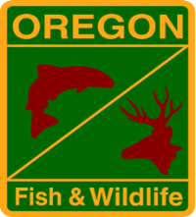

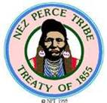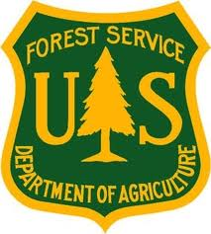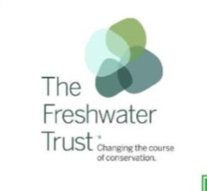

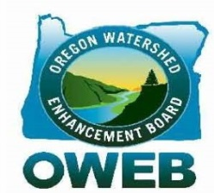

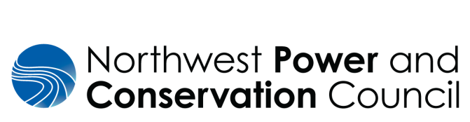

January, 2019

Table of Contents
1 Introduction 4
1.1 Atlas Overview 4
1.2 Implementation Guidelines Statement 5
2 Atlas Roles and Responsibilities 7
2.1 Development Team and Implementation Team 7
2.1.1 Atlas Development Team 7
2.1.2 Atlas Implementation Team 7
2.2 Grande Ronde Model Watershed 8
2.3 Grande Ronde Model Watershed Board 8
2.4 Action Agencies 9
3 Atlas Mechanics 10
3.1 Selection of Conceptual Restoration Opportunities 10
Step 1: Selection of Opportunities and Leads 10
Step 2: Prospectus Phase 11
Step 3: Proposal Phase 12
3.2 Land Owner Communication 14
3.3 Management of Atlas Products (Maps, Matrices, Data) 14
3.4 Outreach and Community Engagement 14
3.5 Meetings 15
3.5.1 Monthly Coordination 15
3.5.2 Annual State of the Science 15
3.5.3 Extended State of the Science 15
3.6 Public Outreach and Education 16
3.7 Engagement of Regulatory Partners 16
4 Adaptive Management 17
4.1 Investment in the Atlas Framework 17
4.2 Adaptive Management of the Atlas Implementation Guidelines 17
5 Atlas Implementation Guidelines Review 17
Appendices
Appendix A Wallowa Atlas Report
Tables
Table 1 Wallowa Atlas Development Team Members 8
Table 2 Wallowa Atlas Implementation Team Members 8
Figures
Figure 1 Development of Atlas Conceptual Restoration Opportunities 10
Figure 2 Visual summary of conceptual restoration opportunity selection, prospectus, proposal, and final approval phases 13

Introduction
The Atlas Implementation Guidelines document includes the objectives, products, roles, responsibilities, and mechanics necessary to implement the Atlas in Wallowa County.

Atlas Overview

The Bonneville Power Administration (BPA) collaborated with several local partners in the Grande Ronde Subbasin to develop the Atlas in Wallowa County. The Atlas is a dynamic tool that utilizes existing empirical data, current research evidence, and the knowledge of local biologists to create a collaborative, strategic, and prioritized habitat restoration implementation plan. The Atlas does not duplicate previous planning efforts, including Subbasin Plans and Recovery Plans. Rather, it synthesizes critical information from these previous efforts to strategically identify and prioritize targeted restoration actions and locations to improve aquatic habitat and increase the productivity, abundance, and distribution of focal fish species (spring/summer Chinook salmon, fall Chinook salmon, coho salmon, summer steelhead, Pacific lamprey, and bull trout).

Atlas Objectives

- Establish collaboration among the local natural resource management partners.
- Utilize existing planning documents, assessments, empirical data, and research evidence at the local level to inform habitat restoration.
- Prioritize the location and type of restoration actions needed to address the key factors that limit the productivity, abundance, and distribution of focal fish species.
- Implement high priority, strategic habitat restoration projects that produce measurable results.
- Maintain a living and collaborative prioritization framework that demonstrates objectivity, transparency, and accountability.
- Manage the prioritization framework and associated project implementation adaptively to ensure maximum biological benefit.
The Atlas development phase involves the review of existing planning documents, assessments, results of research and monitoring, empirical data, and current scientific literature to identify the biological and physical habitat conditions needed to increase the productivity, abundance, and distribution of the focal species within a watershed. Data and information are presented in a spatial context with GIS technology to evaluate species utilization, stream reach subdivision (subwatershed), and to perform a limiting habitat factors assessment. This process results in a list of specific restoration action types intended to address the limiting factors within the individual subwatersheds. Next, GIS data are utilized to identify the associated conceptual restoration sites on the landscape where specific habitat improvement actions would provide the most biological benefit. Once identified, these conceptual restoration opportunities are scored and ranked using biological criteria.

Atlas Products

- A set of scored and ranked subwatersheds within the watershed analysis area
- A set of scored and ranked conceptual restoration opportunities with the associated site maps within each ranked subwatershed
- Centralized data and map repository with information about fish life history stages and their habitat requirements, limiting habitat factors, subwatersheds, and conceptual habitat restoration opportunities.

Implementation Guidelines Statement

These implementation guidelines define the roles and responsibilities of Subbasin natural resource management partners to implement and adaptively manage the Atlas in Wallowa County. The Atlas is a living document that will be reviewed and updated every two years, or as determined necessary, to address unforeseen circumstances, provide lessons learned from implementation, maintain implementation progress, and incorporate current research, monitoring, and evaluation results. Ultimately, the success of Atlas implementation will be dependent upon the ability of the local natural resource management partners to work collaboratively with land owners and land managers to accomplish common restoration goals.

Atlas Partner Roles

- Support of the Opportunity Lead: High priority conceptual restoration sites (See Section 3.1) will be assigned a lead who is responsible for land owner outreach and development of this concept into a restoration opportunity. To ensure the lead is successful, the Atlas partners will support the Opportunity Lead as they work to develop the project opportunity into a viable project.
- Commitment to a Shared Vision: Atlas partners recognize that success is founded on a commitment to and understanding of the Atlas. While Atlas participation is voluntary, Atlas partners will share this understanding with other entities and organizations to build synergistic relationships with non-participating entities and respect the Opportunity Lead as the point of contact.
- Atlas Resource Management: A common data repository serves as the archive for Atlas products, including the ranked subwatersheds, associated restoration opportunity maps, prioritization matrix, and future iterations/revisions of these documents. This information will be used by the Implementation Team (See Section 2.1.2) to facilitate the restoration strategy and assign Opportunity Leads. Maps that depict general action types at various locations can be shared within outreach documents to improve the transparency and understanding of the objectives of the Atlas.

Atlas Partner Roles

- Product Dissemination: Atlas partners acknowledge that the way in which Atlas products are shared with the general public, and more specifically with private land owners (potential cooperators), is of utmost importance and very sensitive. Thus, collectively the partners will strive to disseminate this information in a way that best facilitates the Atlas framework by respecting the role of the Opportunity Lead, the sensitivity of the information, and minimizing duplication regarding land owner/public contacts associated with Atlas derived project opportunities.

- Commitment to Biological Resources: Atlas partners understand that the adoption of an evidence-based, strategic restoration prioritization framework requires a common strategy and alignment of resources. Although the subject watershed may be impacted by a multitude of land management practices, the Atlas is focused on prioritizing the investment for the habitat improvement and biological benefit of the focal fish species (spring/summer Chinook salmon, fall Chinook salmon, coho salmon, summer steelhead, Pacific lamprey, and bull trout).
Atlas Roles and Responsibilities

2.1 Development Team and Implementation Team
A Development Team and an Implementation Team have been created to support the development, implementation, and adaptive management of the Atlas. The Development Team develops the Atlas by objectively determining subwatershed rankings and a ranked list of conceptual restoration opportunities, with the associated site maps, that would provide the most biological benefit. The Implementation Team then works collaboratively to evaluate the feasibility and policy components required to prioritize, develop, and implement these project opportunities. The roles and objectives of the Development Team and the Implementation Team are described in more detail below.

2.1.1 Development Team: Atlas Development
The Development Team includes the personnel of each Atlas partner with core competencies in fish biology and applied habitat restoration, and who have specific knowledge of the given watershed. These local and regional research and habitat biologists, ecologists, geomorphologists, and engineers evaluate the available empirical data on fish use, periodicity, and limiting habitat factors to define subwatersheds. The Development Team then recommends restoration action types, from a biological perspective, which would address the identified limiting habitat factors. Products developed by the Development Team include subwatershed and conceptual restoration opportunity scoring matrices, and the associated conceptual restoration site maps at the watershed scale.

The Development Team will also be responsible for reviewing and evaluating the status of the Atlas as projects are completed, incorporating new scientific research and/or monitoring information, and performing a periodic review of the opportunity scoring matrix as part of the Wallowa County annual “State of the Science” meetings described in Sections 3.6.2 and 4. The Development Team will also serve as a technical resource for the Implementation Team as needed for specific tasks such as assessing the biological merits of an opportunity outside of a priority subwatershed. Table 1 below provides a current list of Development Team members.

2.1.2 Atlas Implementation Team
The Implementation Team includes the personnel of each Atlas partner with significant restoration implementation experience, and whenever possible, experience working with local land owners and land managers. The Implementation Team members are selected by each Atlas partner, and generally include one representative and one alternate from each organization. The Implementation Team replaces the Wallowa County Technical Team and determines the feasibility of the ranked project opportunities provided by the Development Team. Table 1 below provides a current list of Implementation Team members.

The Implementation Team will be responsible for assigning each priority conceptual restoration opportunity an Opportunity Lead. The Opportunity lead, with Implementation Team support, will be responsible for developing each qualifying high priority conceptual restoration opportunity into a prospectus, and ultimately a project proposal. This implementation approach will focus opportunity development on the highest value restoration projects through a cycle of identification, prioritization, and refinement of restoration opportunities. The process for performing this role is described in more detail in Section 3.
Wallowa Atlas
Table 1 – Development Team Members |  |  | Table 2 – Implementation Team Members
GRMW | Menton, Steele |  | GRMW | Menton, Steele
BPA | Kaplowe, Welch |  | BPA | Kaplowe, Welch
 |  |  | WR | Jancaitis, Christoffersen
NOAA | Morrow |  | NOAA | Morrow
USFWS | Stephenson |  | USFWS
USFS | Miller |  | USFS | Miller
FWT | Humphreys |  | FWT | Humphreys
NPT | Frenyea, Pagano |  | NPT | Frenyea, Pagano
ODFW | Sedell, Yankee, |  | ODFW | Sedell, Bratcher
 | Bratcher, Fagan, Morton

Grande Ronde Model Watershed
As the local coordination entity, the Grande Ronde Model Watershed (GRMW) will be responsible for facilitating the implementation of the Atlas. This will include arranging and facilitating Development Team and Implementation Team meetings, and providing the associated meeting notes and action items. GRMW will lead project site visits with the Implementation Team, and provide written technical feedback, ranking decisions, and funding recommendations consistent with the Atlas framework as described below in section 3.2. GRMW, with the assistance of other local partners, will also conduct education and outreach related to the Atlas, and provide a variety of services such as meeting and site visit logistics, maintenance of a readily accessible Atlas data repository, GIS layer production, and information technology assistance.

Grande Ronde Model Watershed Board
The role of the GRMW Board will be to provide policy, socioeconomic, and other resource management guidance for Atlas implementation. The Board will support outreach to respective constituencies and determine, by vote, approval for Atlas proposals and projects. The Board will also provide input to the Implementation Team on Atlas project proposals. The Board will review project prospectuses only if requested by the Implementation Team.

Action Agency
Bonneville Power Administration (BPA) recognizes the need and benefit of strategic restoration to help meet their commitments under the Northwest Power and Conservation Council’s Fish and Wildlife Program as well as the FCRPS Biological Opinion. Financial and technical resources contributed by BPA will be directed to projects prioritized and selected by the Atlas framework.

Bonneville Power Administration (BPA)
BPA will support the Development Team and Implementation Team with Atlas implementation as an advisor for technical and funding related items, and as a mediator when necessary to resolve conflict. BPA will evaluate projects proposed for funding that have been objectively identified and prioritized by the Atlas. Funding for projects developed outside of the Atlas framework will be considered on a case by case basis.

Atlas Mechanics
An overview of the process used to develop a conceptual restoration opportunity is provided here in Figure 1. Additional details on the mechanics of the process are described below.

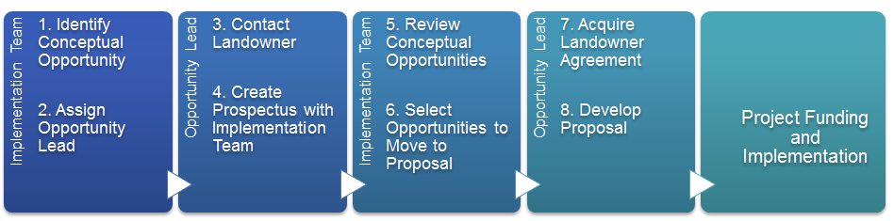
Figure 1 - Development of Atlas Conceptual Restoration Opportunities

3.1 Selection of Conceptual Restoration Opportunities

Step 1: Selection of Opportunities and Leads

Effective implementation of the Atlas will require frequent communication between the Implementation Team and the Development Team. The Implementation Team will meet on a monthly basis, and will also convene during the spring and fall solicitations to strategically review and determine which Atlas identified conceptual restoration opportunities to pursue. This will lead to the development of a multi-year implementation strategy that will identify the necessary technical and financial resources. Should potential opportunities arise outside of this formal Atlas process, they will be discussed at the monthly meeting and with BPA. The Implementation Team will determine if the potential opportunity ranks high enough, and if resources are collectively available to assign an Opportunity Lead. Opportunities within Tier 1 subwatersheds, and with the ability to address the most limiting habitat factors, as evaluated within the prioritization matrix, will be the primary focus. The Implementation Team will also evaluate:

- Whether high priority Tier 2 subwatershed conceptual restoration opportunities should be pursued prior to lower Tier 1 subwatershed priorities
- Whether conceptual restoration opportunities that provide less than optimal biological benefit for a commensurate level of investment should proceed
- Whether conceptual restoration opportunities that have not previously been evaluated by the Atlas framework are of sufficient value to proceed

The Implementation Team will consider how to most effectively use the collective resources of the Atlas partners to achieve aquatic habitat restoration in an expedient and efficient manner that balances involvement by the partners. The Opportunity Lead will be selected by the Implementation Team, and may be the individual that can best leverage an existing land owner relationship and/or the individual whose expertise aligns well with the type of conceptual restoration opportunity. The Opportunity Lead, with the support of the Implementation Team, will be responsible for advancing the conceptual restoration opportunity through the prospectus, proposal, and implementation phases using the process outlined in Section 3.2 below, unless otherwise designated by consensus of the Implementation Team.

Conceptual Restoration Opportunity Development

Step 2: Prospectus Phase

Once a conceptual restoration opportunity has been prioritized and the Implementation Team has assigned an Opportunity Lead, it enters the prospectus phase. Since there are multiple factors that influence the development of a conceptual restoration opportunity, it will often change relative to its initial concept. The prospectus phase provides the Opportunity Lead with time to work with the land owner to account for these factors. During that time, the Opportunity Lead will keep the Implementation Team informed of circumstances that might affect whether the project can be developed fully enough to achieve the intended benefits. This may include additional restoration conceptual restoration opportunities that should be included in the prospectus, significant changes in the feasibility score, or potential challenges. Monthly coordination meetings will be the formal venue for this communication to occur so partners are kept informed. Once the land owner has agreed to a conceptual restoration opportunity, the Opportunity Lead, in conjunction with any supporting entities, will utilize the forms on the GRMW website to generate a project prospectus that describes the type and scale of restoration actions planned.

The Opportunity Lead will then present the completed prospectus to the Implementation Team which will vote on whether to advance the prospectus to the proposal phase. Depending on how much the conceptual restoration opportunity has changed since its inception, the Implementation Team may re-calculate the conceptual restoration opportunity score, using the prioritization matrix, to help inform their decision. GRMW staff will keep the GRMW Board apprised of conceptual restoration opportunities in the development phase. The GRMW Board will not review project prospectuses unless requested by the Implementation Team. Conceptual restoration opportunities that do not advance because their potential biological benefit has been reduced by feasibility constraints may be placed on hold. These conceptual restoration opportunities will be documented by GRMW and maintained in the Atlas prioritization matrix. The Opportunity Lead will be responsible for providing updates to the land owner.

Conceptual Restoration Opportunity Development

Step 3: Proposal Phase

Once the Opportunity Lead has developed a draft project proposal, GRMW will facilitate technical review and a project site visit by the Implementation Team. The Implementation Team is responsible for providing feedback on items that may impact the project’s technical execution, cost effectiveness, and/or sustainability.

This review process will provide a quality assurance mechanism for the Opportunity Lead and the Implementation Team, as well as a venue for the Implementation Team to discuss the technical and biological merits of the proposed project. During the site visit, the Implementation Team and Opportunity Lead will discuss any relevant issues such as expected biological benefit, technical design considerations, and suggestions for improving the proposed project. Within three weeks following the site visit, the Opportunity Lead will receive a written site visit report prepared by GRMW that incorporates the Implementation Team recommendations. The report will contain written feedback on the proposed project’s likelihood of meeting biological objectives.

Once received, the Opportunity Lead will address comments and prepare a final proposal if recommended by a majority of the Implementation Team. An Implementation Team representative from GRMW will support the Opportunity Lead by addressing questions, concerns, or requests for additional information. When complete, the final proposal will be submitted to the Implementation Team for a final review and then submitted, along with any Implementation Team recommendations, to the GRMW Board of Directors for a vote to determine whether the proposed project should be approved for funding.

Ultimately, the prospectus and proposal phases will be conducted concurrently, for multiple conceptual restoration opportunities, throughout the cycle (See Figure 2 below).

Figure 2 – Visual summary of conceptual restoration opportunity selection, prospectus, proposal, and final approval phases

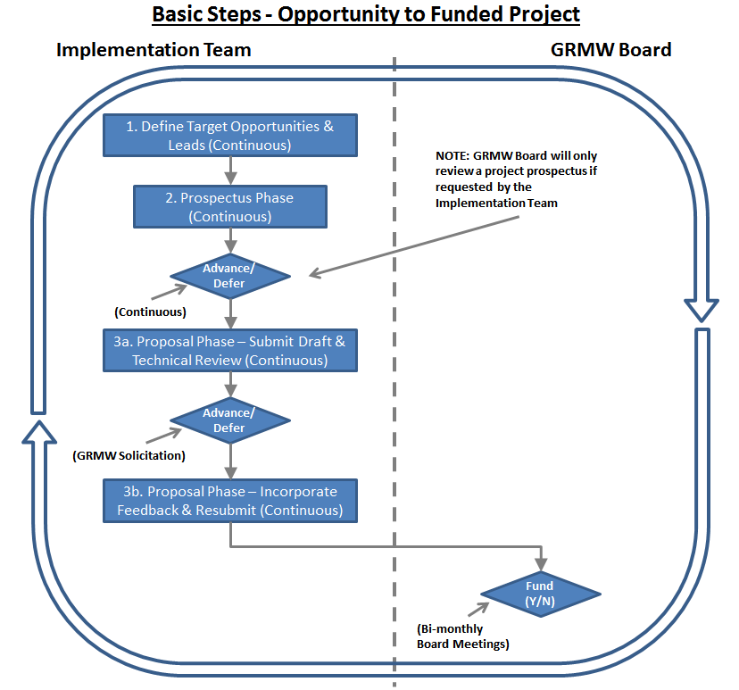

Land Owner Communication

Establishing and maintaining the trust and respect of private land owners is fundamental to the success of the Atlas. As a result, land owner outreach will be coordinated by the Implementation Team to avoid confusion or duplication of effort. The Opportunity Lead will serve as the primary point of contact with the cooperating land owner for each project opportunity.

The Opportunity Lead will typically use two tiers of mapping to have discussions with the land owner. Initially, an overview map will be used to discuss the opportunity, including potential restoration actions. As the prospectus develops, the Opportunity Lead will present a more detailed concept map, specific to their property.
Should a member of the Implementation Team, Development Team, GRMW staff, or GRMW Board be directly contacted by a land owner after an Opportunity Lead has been assigned, they will inform the Opportunity Lead and GRMW so that the lines of communication can be clarified.

During prospectus development, the Opportunity Lead will request that the land owner sign a letter of intent to proceed with the potential project. Once a project opportunity is ready to move beyond the preliminary design phase, and prior to the commitment of resources, the Opportunity Lead will request written authorization from the land owner to implement restoration actions. This may be a written cooperative agreement or a more comprehensive conservation easement.

Should restoration entities outside of the Implementation Team and Atlas partners engage in land owner outreach, GRMW will encourage collaboration with the Atlas framework and participation with the Implementation Team.

3.3 Management of Atlas Products (Maps, Matrix, Data)

Atlas products will be housed by GRMW. This includes RM&E data, the subwatershed determinations, prioritization matrix, the overview maps, and detailed concept maps. These products will be a valuable resource to inform ranking, selection, and development of project opportunities. GRMW will provide training, as needed, regarding the access and utilization of these products.

3.4 Outreach and Community Engagement

GRMW, with the assistance of the Implementation Team and other collaborating organizations, will perform public outreach to engage land owners in the Subbasin with the Atlas framework and products. The primary goal of the outreach efforts is to provide the land owners with an appropriate level of understanding of the Atlas and reduce the risk of misinterpretation by the entities and land owners that manage or own the land within the watershed.

Atlas Meetings

3.5.1 Monthly Coordination

The Implementation Team will hold monthly Restoration Coordination Meetings in Wallowa County, Oregon. These meetings will provide an opportunity to check in and provide feedback on opportunities that are being developed, as well as discuss new opportunities that have surfaced due to land owner interest. Meeting notes and action items will be recorded and sent to the Implementation Team within two weeks of the meeting.

3.5.2 Annual State of the Science

The Implementation Team will coordinate an annual State of the Science meeting with the Development Team, to review conceptual restoration opportunities developed and pursued during the previous year, restoration actions completed, and any new research to inform future project planning and implementation. The agenda, including specific objectives, will be developed collaboratively with the Development Team and GRMW staff.

The general outline for this meeting will include:
- Review of conceptual restoration opportunities developed and pursued during the previous year.
- Review of restoration projects completed during the previous year.
- Summarize lessons learned and adaptive management strategies to enhance future project implementation.
- Incorporation of any current research to inform project planning, prioritization, and implementation.
The second half of the annual State of the Science meeting will include a more technical and focused session between the Implementation Team and the Development Team to determine if additional data, research evidence, or recent adaptive management strategies require an update of the Atlas priority areas and/or priority actions. Any updates to the priority areas, priority actions, or prioritization matrix will be documented by GRMW and stored with all of the other Atlas materials. Information from the Annual State of the Science meetings will be used to inform the adaptive management process (Section 4).

Public Outreach and Education

Prior to releasing any Wallowa Atlas products, GRMW, with the assistance of other local partners, will develop a public outreach plan to educate land owners in the Subbasin about the Atlas and its objectives. As part of this plan, public meetings for land owners will be held regularly to explain the Atlas framework, provide updates, answer questions, and identify opportunities for land owner engagement.

3.7 Engagement of Regulatory Partners

Regulatory partners will be engaged early in the project development process to ensure timely completion of projects. The Opportunity Lead, with the support of the Implementation Team, will be responsible for coordinating project specific environmental compliance and permitting processes, scheduling meetings with regulatory agencies, and developing strategic plans to complete permits and consultations in a timely manner to ensure efficient project implementation.

Adaptive Management
The Atlas framework has identified baseline physical habitat and biological conditions for Wallowa County. As projects are implemented, information will be collected and the results will be utilized by the Development Team on a periodic basis as described below to reassess the prioritization of project areas and opportunities within the watershed to ensure development efforts are focused on the conceptual restoration opportunities with the potential to provide the most biological benefit.

Investment in the Atlas Framework

The strategic action plans generated from evidence-based prioritization frameworks such as the Atlas are often used as a mechanism to attract and secure additional funding. Organizations such as the Oregon Watershed Enhancement Board, Ecotrust, Natural Resources Conservation Service, and the US Fish and Wildlife Service have all used evidence-based, prioritized watershed restoration implementation plans to make funding decisions. It is the intention of the participating organizations that the Atlas framework strengthens relationships with funding partners. The effectiveness of the Atlas framework can be enhanced as the local partners and funding entities begin working collaboratively to achieve common habitat restoration objectives.

Adaptive Management of the Atlas Implementation Guidelines

The Atlas Implementation Guidelines is a living document that is expected to be modified over time. Implementation Guidelines revision shall be performed with concurrence of Atlas partners and BPA as future improvement opportunities or risks are identified.

5 Atlas Implementation Guidelines Review
The Atlas Implementation Guidelines will be reviewed periodically to ensure that the objectives are being accomplished effectively and efficiently.

